

**Project Report**

**On**

**LU Exam Hive**

**Project Supervisor:**

**Minhazul Haque Bhuiyan**

Assistant Professor & Assistant Proctor

Department of Computer Science and Engineering

Leading University, Sylhet, Bangladesh

**Submitted By:**

**Mohammed Saduzzaman Sadi ID:** 1712020101

**Toufique Ahmad ID:** 1712020113

**Mohi Uddin Pabel ID:** 1712020128

B.Sc. (Hon’s) in CSE

Session: 2017 -2020

Department of Computer Science and Engineering

Leading University, Sylhet, Bangladesh

A project paper submitted in partial fulfillment of the requirements for the degree of Bachelor of Science in Computer Science and Engineering.

**CERTIFICATION OF REPORT**

This is to certify that the work presented in this report is the outcome of the investigation carried out by the candidates under the supervision of Minhazul Haque Bhuiyan (Assistant Professor & Assistant Proctor of the Department of Computer Science & Engineering).

**Supervisor**

**…………………………………….**

**Minhazul Haque Bhuiyan**

Assistant Professor & Assistant Proctor

Department of Computer Science & Engineering

Leading University, Sylhet, Bangladesh.

**Submitted by:**

Mohammed Saduzzaman Sadi Toufique Ahmad Mohi Uddin Pabel

ID: 1712020101 ID: 1712020113 ID:1712020128

Department of Computer Science & Engineering

Leading University, Sylhet, Bangladesh.

**Preface**

Our first and foremost gratitude is to our GOD Almighty who has been with us all along and giving us the strength to complete the Final Year Project successfully.

We like to share our sincere gratitude to our project supervisor, Minhazul Haque Bhuiyan for his continuous support towards this project.

During the work we faced many challenges due to our lack of knowledge and experience. And our supervisor helped us to get over from all the difficulties and in final compilation of our idea to a shaped sculpture. His suggestions and guidance helped us a lot to prepare this report in a well-organized manner.

We are also thankful to our whole class and most of all to our parents who have inspired us to face all the challenges and win all the hurdles in life.

The report documents of this project work performed in the course CSE-4800 & CSE-4801 “Project II/Thesis” by Mohammed Saduzzaman Sadi, Toufique Ahmed, and Mohi Uddin Pabel. Project II/Thesis counts for 6 credit points and is executed by dividing it into two parts in two semesters. In the 11th semester CSE-4800 for Project Proposal which is 3 credit and in the 12th semester CSE-4801 for the Project Submission which is also 3 credit. Total 6 credits.

The project intends to give Leading University an Online Exam Platform for teachers to take exams and students can give exams remotely.

**Supervision Agreement**

The program outlined in the project is adequate for the degree of Bachelor of Science in Computer Science and Engineering. The supplies and facilities are available and we are willing to supervise and evaluate the project work.

**Supervisor Signature**

$$_________________________________________$$

**Minhazul Haque Bhuiyan**

Assistant Professor & Assistant Proctor

Department of Computer Science & Engineering

Leading University, Sylhet, Bangladesh.

**Students Signature**

$$\frac{ }{Mohammed Saduzzaman Sadi} \frac{ }{Toufique Ahmad} \frac{ }{Mohi Uddin Pabel}$$

**LU Exam Hive**

**Abstract**

The purpose of the project “LU Exam Hive” is to create a web based online examination system. The website is supported in both Desktop and Smartphone platform.

Exam questions can be created by the teachers once they are logged into their account. Question type can be chosen and number of questions is dependent on the teacher’s preference. Questions are displayed in tabular format in the dashboard. Teacher can edit or delete a question. Questions will be available for students once the teacher posts it in a publicly viewed post page that is visible for both teacher and students.

Students have to register to the website first in order to gain log in access. After log in the can see all the available questions in the post page in a tabular format with all the required information about the question. From there they have to choose their course teachers question, which can be identified by the information given on the question.

Once student selects the question, it will redirect to the answer script where they will have to fill up a little form about themselves to verify that he/she is an actual student. Then they can write or choose the answer of the questions that are available and given by the teacher. Once they are finished, they can submit the answer script.

Teacher can specify a time as a deadline for submitting the answer script. They can decide to accept the answer script or not based on the time given and there will be the exact timestamp of when the student submitted the script.

The significance and purpose of this work is to provide a user friendly and reliable web based online examination system for the teachers and students of Leading University.

Table of Contents

Chapter 1: Introduction 1

1.1 The Project 2

1.2 Website 2

1.3 Web Project 3

1.4 Highlights of Web Project 3

1.5 Problem Definition 3

1.6 Project Contribution 3

Chapter 2: Background 4

2.1 Primary Focus 5

2.2 Prerequisites and Key Reasons 5

2.3 Execution Plan 6

2.4 Expected Outcome 7

Chapter 3: System Analysis 8

3.1 Existing System 9

3.2 Drawbacks of Existing System 9

3.3 Proposed System 9

3.4 Advantages of Proposed System 9

Chapter 4: Requirement Specification 10

4.1 Overall Description 11

4.2 External Interface Requirements 12

4.3 System Features 14

4.4 Website Attributes 21

Chapter 5: System & Database Design 22

5.1 System Design 23

5.2 Database Design 28

Chapter 6: Software & Other Tool Requirement 30

6.1 XAMPP 31

6.2 HTML5 31

6.3 CSS3 31

6.4 Bootstrap 4.6 31

6.5 JavaScript 31

6.6 jQuery 32

6.7 PHP 33

6.8 MySQL 34

6.9 Apache 35

6.10 Git & GitHub 36

6.11 PHPMailer 38

6.12 Summernote 38

6.13 FPDF 38

6.14 Visual Studio Code 39

6.15 Browsers and others 39

Chapter 7: Evaluation 40

7.1 Platform Evaluation 41

7.2 General Functional Evaluation 41

7.3 Non-Functional Evaluation 43

Chapter 8: GUI Design 44

8.1 UI Flowcharts 45

8.2 UI Design 46

Chapter 9: Implementation 76

9.1 Login-Logout Functionalities 77

9.2 Student Registration Functionalities 78

9.3 Teacher Dashboard 80

9.4 Student Dashboard 83

9.5 Admin Dashboard 85

Chapter 10: Testing 91

10.1 Platform Testing 92

10.2 Requirement Testing 92

Chapter 11: Conclusion 93

11.1 Conclusion 94

11.2 Further Work 94

References 95

# Chapter – 1

# Introduction

## 1.1 The Project

The Internet has revolutionized communications, to the extent that it is now our preferred medium of everyday communication. In almost everything we do; we use the Internet. And this happens through what is called the web or web application. It's also having a greater impact on the education systems too. Also, in recent times, the COVID-19 outbreak sent the world spinning into complete and udder chaos. Going outside was restricted and industries, offices, educational institutions were closed for a long time.

Especially educational institutions are closed till now. At that time educational institutions had to find an alternative way of taking exams and keep other educational activities running. For that, almost every institution had to teach and take exams remotely via various websites. Zoom, Classroom, and other web-based applications became more renowned. The impact is so big that every university is relying on those websites to continue academic activities.

The objective behind developing this website was to facilitate the exam system for Leading University's teachers and students so that they don't have to rely on other third-party web applications for taking exams. The website will allow teachers to take exams and students can attend and give exams remotely. The project is developed mainly with PHP programming language from scratch.

## 1.2 Website

A website (also written as web site) is a collection of web pages and related content that is identified by a common domain name and published on at least one web server. Notable examples are wikipedia.org, google.com, and amazon.com.

All publicly accessible websites collectively constitute the World Wide Web. There are also private websites that can only be accessed on a private network, such as a company's internal website for its employees.

Websites are typically dedicated to a particular topic or purpose, such as news, education, commerce, entertainment, or social networking. Hyperlinking between web pages guides the navigation of the site, which often starts with a home page.

Users can access websites on a range of devices, including desktops, laptops, tablets, and smartphones. The software application used on these devices is called a web browser.

The World Wide Web (WWW) was created in 1990 by the British CERN physicist Tim Berners-Lee. On 30 April 1993, CERN announced that the World Wide Web would be free to use for anyone. Before the introduction of the Hypertext Transfer Protocol (HTTP), other protocols such as File Transfer Protocol and the gopher protocol were used to retrieve individual files from a server. These protocols offer a simple directory structure which the user navigates and where they choose files to download. Documents were most often presented as plain text files without formatting or were encoded in word processor formats.

## 1.3 Web Project

A web project is the process of developing and creating a Web site, activities in a network which are aimed at a pre-defined goal. The network can be both accessible for everyone, as in the Internet, or only for certain people, as an intranet. The goal of Web projects is the transfer of static and dynamic content - both directly to end users, as well as indirectly through means of various kinds of interfaces. Web projects are based on TCP/IP (Transfer Control Protocol/Internet Protocol) technology and concern the transfer of static and dynamic content.

## 1.4 Highlights of Web Project

A Web project involves many aspects, including programming and the accompanying software development, Web business, Web server and network administration, hosting, graphics/design, the development and administration of databases, construction of interfaces, project management and quality assurance, and much more.

Programming for a web project may be accomplished using one or more markup languages (such as HTML, CSS, XML), scripting languages (JavaScript, Perl, PHP for example).

When hosting a Web project, the primary objectives include the provision of the necessary hardware and software infrastructure, and an assurance that the highest possible levels of availability and reliability are offered. Graphic/Web design for Web projects must offer a high quality of use for persons interacting with the website. Agile project management methods (e.g., Scrum) are used for the management of modern Web projects in order to respond to changes in customer requirements and constraints as the project progresses. The project manager is responsible for the efficient and result-oriented programming of the Web project.

## 1.5 Problem Definition

The project is to anticipate the impact of using the traditional web-based online examination systems for our university. All the systems that are used to continue the academic activities, especially during this pandemic, are third party programs that have both advantages and disadvantages. Also, most of them, especially programs that used to take exams, have many limitations. As a result, faculty members have to use different web applications to teach the students and take exams.

## 1.6 Project Contribution

The main contribution of the project is to present an extensive understanding of how to bring about the examination system remotely through a web platform. Now a web platform is supported in almost all kinds of devices that can access the web. However, the goal of this project is to construct a website for devices that are helpful for online exams like laptops, tablets, and smartphones. The final prototype covers the basic design and functionalities of LU Exam Hive like generating questions, posting them, process of student giving exam and retrieving the result.

# Chapter – 2

# Background

## 2.1 Primary Focus

The modern education system has been favored a lot by web technologies. Now educational institutions making automated systems that easy to maintain and bring flexibility to the infrastructure. As for taking exams, almost all educational institutions were following the traditional method of taking exams at the exam hall which they should. But in the recent time when the COVID 19 started spreading out and institutions has to close unexpectedly. We had no choice but to stay at home and institutions started their academic activities online like taking classes and tests. They were using various web apps and websites that make the work easy for them. But these various web apps or websites were different from each other. Some have many features, some have less, some are very complex, some are so simple that they missed out on a lot of things. And most lot of them require money for to use their advanced features.

We came up with the idea of creating a web-based online examination system for our final year project that is for our university which would not have any kind of special requirement or anything that makes taking an exam online inflexible for the teachers. Our main focus is to create a web-based online examination system for our university, so the teachers do not have to depend on other third-party websites to take exams. And we believe as Leading University is one of the most prestigious university in Sylhet and in whole Bangladesh, we should have our own online platform for teachers and students to take part in exams. And the recent time had shown us how things could change at any time. So, it's always good to have an alternative way of taking exams for the university. And the most efficient, reliable way would be through websites or web-based online examination system.

## 2.2 Prerequisites and Key Reasons

Our proposed project, the "LU Exam Hive," is essentially an online examination system for Leading University. And the core reasons are:

* Leading University does not have its online examination system.
* The sudden pandemic occurrence made us realize we need an online solution for taking exams remotely.
* Other third-party solutions are inflexible for a lot of reasons.
* Leading University could have their own solution.
* Leading University teachers do not have to rely on third-party solutions.

The prerequisites would be to have a better understanding of how the web works. Then plan a solution for the whole scenario. Then construct a design of the solution. Then to put this on the web and provide it its required functionalities. Implement with the markup, programming language, creating database, and all other necessary things that require to full fill the project. And the most important thing is to make sure that we can do it.

## 2.3 Execution Plan

First up, we have to acquire the essential knowledge of the fundamentals like the required programs, programming languages, and other necessary things to build the project. The Scrum approach would be followed to execute the project. The Scrum approach is a general Agile method and its focus on managing iterative development rather than specific agile practice.

Three phases of Scrum:

* The initial phase, the planning where the objectives for the project and software architecture design are established.
* Followed by a series of sprint cycles, where each cycle develops an increment of the system.
* The last phase, the project closure phase wraps up the project, completes required documentation such as system help frames and user manuals.

It is expected to conclude the project in time, within a number of sprint cycles. The project work will be conducted by our project supervisor 'Minhazul Haque Bhuiyan'. Supervisor would be reported, after the development of a major increment of the project.

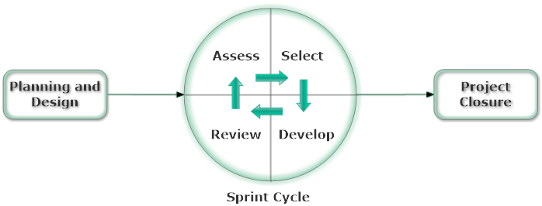

**Figure 1:** The Sprint Cycle of Scrum.

## 2.4 Expected Outcome

As we proceed throughout the final year project, obviously we need to set the goal of what we want to achieve. The proposed project LU Exam Hive is an online examination platform. And as we stated in the project proposal, the desired outcome of the project would be to; provide a fully functional web-based online examination system for Leading University. It will have three types of users. 1. Teacher, 2. Student, 3. Admin.

Primarily as of our plan, the users will have the following functionalities:

1. Teacher:

* Login and logout.
* Create questions and make them available for students.
* A dashboard to manage questions, and other functionalities.
* Edit the question before making them available for students.
* See the answer script of students and mark them.

1. Student:

* Login and logout.
* See available questions.
* Select and write answers for the specific set of question.
* Submit the answer script.

1. Admin:

* Login and logout.
* Receive and review contact messages.
* Modify, change, delete, or add data through an UI rather then doing it from the database.

# Chapter – 3

# System Analysis

## 3.1 Existing System

Throughout our university time, especially during the pandemic situation. We have experienced the use of many web-based online examination systems. The most notable of them are the Google Form and the FlexiQuiz. Though there are many systems like these are available, these two are very common and used widely. Other websites like the "think exam" have many features like Question Bank, Candidate Management, Test Creation, Monetize, Test Taker Panel, Optimum Reporting System, etc. Per questions, a user can have only 30 other people take the exam in the free trial, which is also only for 30 days. SpeedExam is another popular platform for taking exams online and just like "think exam," it requires money to get advanced features. Every system has somewhat identical features but most of them vary from one another. Google Form is mainly a service that helps someone to take surveys via form and it is one of the best. As it is a survey administration software or system it is not very effective for taking academic exams. As a result, our faculty members use FlexiQuiz along with Google Form for its flexibility in taking exams and providing results.

## 3.2 Drawbacks of Existing System

* Features of them vary from one another.
* Some have most of the features but, features are limited for non-premium users.
* Free systems do not have most of the required functionalities.
* One system that does not provide a particular service, may be available in another system.
* As a result, users may have to use more than one system.
* All of these systems are third party and none of them belong to Leading University.
* User data including all data of student's exams are stored in a third-party database.
* Full version systems are paid one.

## 3.3 Proposed System

The proposed system entitled “LU Exam Hive” is going to be an own product Leading University. That would be maintained by the staff including; faculty members of Leading University. And also, would be used by the students for the exams that require to take online. As of now, it will only be available for the Department of Computer Science and Engineering. Teachers can have a platform to take the exam remotely with advanced features and they do not have to pay for it.

## 3.4 Advantages of Proposed System

* Teachers would not have to pay to use its advanced features.
* Almost all required features are available.
* Any modification or any features can be included, according to user’s need.
* Leading University stuff will have full control over the system.

# Chapter – 4

# Requirement Specification

Having explored a few existing web-based online examination systems and determining the functionalities of LU Exam Hive. We have initially come to a conclusion. And this chapter describes all the requirements for LU Exam Hive. Our team will develop the Online Examination System for Leading University

## 4.1 Overall Description

### 4.1.1 Product Function

The Online Examination System LU Exam Hive (LUEH) provides a range of features and functionalities. It is a system that enables the students and teachers of Leading University to take online exams more conveniently. Following are a list of some of the functionalities that the website will provide:

* Administrator user.
* Supports multiple users.
* The administrator can control users.
* User registration and login.
* OTP Verification.
* Dashboard for all users.
* Create questions.
* Manage questions.
* Take exam.
* Prepare result.
* Displaying individual results.
* Lists of posted questions.
* Personalized table of questions.

### 4.1.2 User Classes and Characteristics

**LUEH General Members and non-members:**

Most of the general users of the LUEH are familiar with web browsers and web-based interfaces and interactions.

**Teachers and Students:**

Teachers and Students are good enough in almost all web-based online examination system operations as well as familiar with the basic interactions of websites.

**System Manager:**

The system manager is a technical person who has expert knowledge to operate the online examination system. He is also familiar with website management operations.

### 4.1.3 Constraints

The following are a general list of constraints that would delimit the developer’s options while building the LUEH:

1. The system shall be able to use the MySQL database.
2. The system shall be able to run on most web browsers like Chrome, Opera, Firefox, Safari, Microsoft Edge.
3. The system shall be able to run on mobile devices like Android and IOS.
4. The system shall never store historical data of a user only information related to exams and management purposes.

### 4.1.4 Assumptions and Dependencies

As website reliability depends on its server and good server with higher performance is very costly. We assume that we will have to “pave our own way” concerning programming the majority of the website and the database, due to the mostly closed-source and secretive nature of major online examination systems. For what we cannot find from open documentation and research, it is assumed that we will have to deduce how LUEH standards and database work from observing external behaviors found in existing online examination systems, and we will have to replicate the results using our own code and design.

## 4.2 External Interface Requirements

### 4.2.1 User Interfaces

User interfaces for all users will be graphical user interfaces (GUI). These GUI will be web-based and accessible via a web browser.

**Teachers:**

The teacher interface would enable the teacher to perform all the functionalities which the system provides for this type of user. Teachers will be able to log in, create questions, see submitted answers, make results, log out, etc.

**Students:**

This interface allows the students to register, log in, see personalized questions, take exams, logout. These features will also be available through the web interface.

**System manager or Admin:**

The system manager interface would enable the manager to perform all the functionalities which the system provides for this type of user. The system manager will be able to perform the same tasks that the other users. Moreover, he will also be able to control the database and take action if required.

**Non-members:**

Any outsider who’s not a teacher, student or a stuff of leading university, will just be able to interact with and visit the index page of the website.

### 4.2.2 Hardware Interfaces

1. Regular PC:

* **Processor:** Dual Core of Higher (SSE3 capable).
* **Ram:** 2GB or Higher.
* **Hard Disk Space:** 1GB or Higher.

### 4.2.3 Software Interfaces

To build the website it will require some software that helps to make a website. A modern browser, a text editor, a local server software, etc. More about software interface will be discussed in Chapter 6: Software Requirements.

## 4.3 System Features

### 4.3.1 Functions

**4.3.1.1 Authentication**

|  |  |
| --- | --- |
| Requirements ID | Functions.Authentication.Login |
| Title | Login |
| Description | The users shall be able to login into the LUEH by entering their email and password |
| Identifier/Source | Minhazul Haque Bhuiyan, Project Supervisor, in a virtual meeting on 02.11.2020 |
| Rationale | The system would have to distinguish users so that they are only authorized to view the data that is meant for them |
| Restrictions & Risks | User might forget username/password |
| Dependencies | For Student: Functions.Authentication.Register |

|  |  |
| --- | --- |
| Requirements ID | Functions.Authentication.Logout |
| Title | Logout |
| Description | The logged in users shall be able to logout of the system |
| Identifier/Source | Minhazul Haque Bhuiyan, Project Supervisor, in a virtual meeting on 02.11.2020 |
| Rationale | Authorized users may want to leave LUEH |
| Restrictions & Risks | N/A |
| Dependencies | Functions.Authentication.Login |

|  |  |
| --- | --- |
| Requirements ID | Functions.Authentication.Register |
| Title | Register |
| Description | The student user shall register into LUEH by entering their email and student info before gaining access to other functionalities |
| Identifier/Source | Team members, in virtual meetings. |
| Rationale | The system would have to distinguish users so that they are only authorized to view the data that is meant for them |
| Restrictions & Risks | Student user may try to register more than once |
| Dependencies | For Students: Functions.Authentication.OTP |

|  |  |
| --- | --- |
| Requirements ID | Functions.Authentication.OTP |
| Title | OTP |
| Description | The student user shall verify their email by using the OTP sent to their email during registration |
| Identifier/Source | Team members, in virtual meetings. |
| Rationale | The system would have to identify users as real person |
| Restrictions & Risks | Valid email address required |
| Dependencies | N/A |

|  |  |
| --- | --- |
| Requirements ID | Functions.Authentication.Forget.Password |
| Title | Forget Password |
| Description | The student user shall reset their password by the link sent to their email in case they forget it. |
| Identifier/Source | Team members, in virtual meetings. |
| Rationale | Users may forget their password |
| Restrictions & Risks | Valid email address required |
| Dependencies | Functions.Authentication.Register |

**4.3.1.2 Manage Question**

|  |  |
| --- | --- |
| Requirements ID | Functions.ManageQuestion.Create Question |
| Title | Create Question |
| Description | The teacher user shall be able to add or create new question to the LUEH database |
| Identifier/Source | Minhazul Haque Bhuiyan, Project Supervisor, in a virtual meeting on 02.11.2020 |
| Rationale | This is needed to add data regarding new question |
| Restrictions & Risks | N/A |
| Dependencies | N/A |

|  |  |
| --- | --- |
| Requirements ID | Functions.ManageQuestion.Post Question |
| Title | Post Question |
| Description | The teacher users shall be able to post the created questions |
| Identifier/Source | Team members, in virtual meetings. |
| Rationale | The teacher users shall be able to post the question so it will be made available for the student users. |
| Restrictions & Risks | N/A |
| Dependencies | Functions.ManageQuestion.Create Question |

|  |  |
| --- | --- |
| Requirements ID | Functions.ManageQuestion.View Question |
| Title | View Question |
| Description | The users shall be able to view a list of available questions |
| Identifier/Source | Team members, in virtual meetings. |
| Rationale | All the users shall be able to view the question so they know what questions are currently available. The student user can then select the particular question and take the exam. |
| Restrictions & Risks | N/A |
| Dependencies | Functions.ManageQuestion.Post Question |

|  |  |
| --- | --- |
| Requirements ID | Functions.ManageQuestion.Edit Question |
| Title | Edit Question |
| Description | The teacher users shall be able to edit the created questions |
| Identifier/Source | Team members, in virtual meetings. |
| Rationale | The teacher users shall be able to edit the question before posting. |
| Restrictions & Risks | Once a question is posted, it shall not be edited |
| Dependencies | Functions.ManageQuestion.Create Question |

|  |  |
| --- | --- |
| Requirements ID | Functions.ManageQuestion.Delete Question |
| Title | Delete Question |
| Description | The teacher users shall be able to delete the created questions |
| Identifier/Source | Team members, in virtual meetings. |
| Rationale | The teacher users shall be able to delete the question before posting or after the exam is done and after publishing the result. |
| Restrictions & Risks | Question shall not be deleted during exam. |
| Dependencies | Functions.ManageQuestion.Create Question |

**4.3.1.2 Manage Answer**

|  |  |
| --- | --- |
| Requirements ID | Functions.ManageAnswer.Submit Answer |
| Title | Submit Answer |
| Description | The student users shall be able to submit the answer. |
| Identifier/Source | Team members, in virtual meetings. |
| Rationale | The student users shall be able to submit the answer for the particular posted question so teacher will get it. |
| Restrictions & Risks | Student might try to submit answer twice for the same question. |
| Dependencies | Functions.ManageQuestion.Post Question |

|  |  |
| --- | --- |
| Requirements ID | Functions.ManageAnswer.Generate Result Document |
| Title | Generate Result Document |
| Description | The teacher users shall be able to generate result document format. |
| Identifier/Source | Team members, in virtual meetings. |
| Rationale | The teacher users shall be able to generate the result in a document format. Preferably in PDF document format. |
| Restrictions & Risks | Naming constraints might affect the document format. |
| Dependencies | Functions.ManageAnswer.Submit Answer |

**4.3.1.2 Manage Users**

|  |  |
| --- | --- |
| Requirements ID | Functions.ManageUsers.Add users |
| Title | Add users |
| Description | The admin shall be able to add new users. |
| Identifier/Source | Team members, in virtual meetings. |
| Rationale | This is needed to add the information about the new members into the LUEH so that they can use the features of the website. |
| Restrictions & Risks | The admin may add incorrect information about the member |
| Dependencies | Functions.ManageUsers.Add users |

|  |  |
| --- | --- |
| Requirements ID | Functions.ManageUsers.View User Information |
| Title | View User Information |
| Description | The admin shall be able to view user’s information |
| Identifier/Source | Team members, in virtual meetings. |
| Rationale | This is needed so that the admin can see their information if anything goes wrong that needed to be fixed. |
| Restrictions & Risks | User may not desire to share some informations |
| Dependencies | Functions.ManageUsers.Add users |

|  |  |
| --- | --- |
| Requirements ID | Functions.ManageUsers.Remove Users |
| Title | Remove Users |
| Description | The admin shall be able to remove users. |
| Identifier/Source | Team members, in virtual meetings. |
| Rationale | This is needed so that the admin can remove users when necessary. |
| Restrictions & Risks | N/A |
| Dependencies | Functions.ManageUsers.Add users |

**4.3.1.3 Backup**

|  |  |
| --- | --- |
| Requirements ID | Functions.Backup.Backup data |
| Title | Backup data |
| Description | The admin shall be able to back up the entire database of the LUEH. |
| Identifier/Source | Team members, in virtual meetings. |
| Rationale | This is to prevent data loss if the system data gets corrupted |
| Restrictions & Risks | The admin may not always be available for backup. |
| Dependencies | N/A |

**4.3.1.4 Performance Requirements**

|  |  |
| --- | --- |
| Requirements ID | PerformanceReq.SimultaneousAccess |
| Title | Simultaneous access to system |
| Description | The website shall be able to handle up to 100 users  simultaneously accessing the system |
| Identifier/Source | Team members, in virtual meetings. |
| Rationale | The system won’t be busy when people want to access  the system |
| Restrictions & Risks | The web server may not be able to handle that much users. |
| Dependencies | Web Server |

|  |  |
| --- | --- |
| Requirements ID | PerformanceReq.Total users |
| Title | Total users |
| Description | The website shall be able to have 1500 members |
| Identifier/Source | Team members, in virtual meetings. |
| Rationale | So LUEH can register new members, potential in all Leading University is 6000, CSE Dept. has around 800 or more members |
| Restrictions & Risks | The web server may not be able to handle that much users. |
| Dependencies | Web Server |

|  |  |
| --- | --- |
| Requirements ID | PerformanceReq.Throughput |
| Title | Throughput |
| Description | The website shall be able to have 1500 members |
| Identifier/Source | Team members, in virtual meetings. |
| Rationale | The throughput time of internet shall be a maximum of five seconds |
| Restrictions & Risks | Users internet may not be reliable |
| Dependencies | Users ISP or Internet Service Provider |

## 4.4 Website Attributes

### 4.4.1 Reliability

1. The LUEH should perform its operations and functionalities without any crash.
2. The LUEH should be able to recover from data loss during website down period, etc.

### 4.4.2 Availability

1. The LUEH website should be available at all times, even during database backups and recoveries. And except during the server down time which should not be long.

### 4.4.3 Security

1. There will be proper user privileges according to the user type i.e., Teacher or Student.
2. Users will be able to login into the system only by using his or her email and password.
3. Passwords will be encrypted, even admin will not see or understand user’s real password.
4. No historical data about users will be saved in the system.

### 4.4.4 Maintainability

The system manager or admin may need to maintain and monitor the website when too many users try to access and performs various functionality.

### 4.4.5 Portability

1. The LUEH website will run its web interface on any operating system that has a web browser installed.
2. LUEH will be fully responsive so any device with a browser can run it.
3. The LUEH web server would be portable to any other server that supports Apache.

# Chapter – 5

# System & Database Design

## 5.1 System Design

Systems design is the process of defining elements of a system like modules, architecture, components and their interfaces and data for a system based on the specified requirements. It is the process of defining, developing and designing systems which satisfies the specific needs and requirements of a business or organization.

A systemic approach is required for a coherent and well-running system. Bottom-Up or Top-Down approach is required to take into account all related variables of the system. A designer uses the modelling languages to express the information and knowledge in a structure of system that is defined by a consistent set of rules and definitions. The designs can be defined in graphical or textual modelling languages. Some of the popular examples of graphical modelling languages are:

* Unified Modelling Language.
* Flowchart etc.

**Unified Modelling Language:**

UML stands for Unified Modeling Language. It’s a rich language to model software solutions, application structures, system behavior and business processes. The purpose of a use case diagram in UML is to demonstrate the different ways that a user might interact with a system. There are two main categories i.e., Structure diagrams and Behavioral diagrams.

* Structure diagrams show the things in the modeled system. In a more technical term, they show different objects in a system.
* Behavioral diagrams show what should happen in a system. They describe how the objects interact with each other to create a functioning system.

**Design methods:**

Design methods are procedures, techniques, aids, or tools for designing. They offer a number of different kinds of activities that a designer might use within an overall design process.

Some popular design methods:

* Architectural design
* Logical design
* Physical design

### 5.1.1 USE CASE DIAGRAM (LU Exam Hive)

Use case diagrams give a graphic overview of the actors involved in a system, different functions needed by those actors and how these different functions interact. It’s a great starting point for any project discussion because you can easily identify the main actors involved and the main processes of the system.

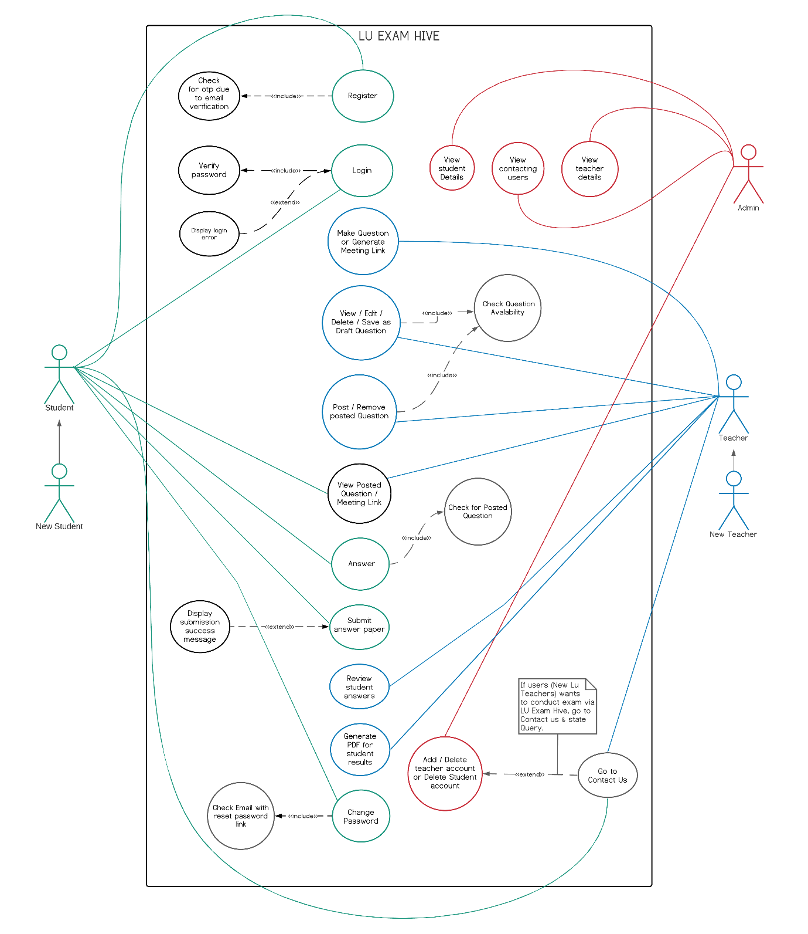

**Figure 2:** Use Case Diagram for LU Exam Hive

### 5.1.2 Activity Diagram (LU Exam Hive)

Activity diagrams represent workflows in a graphical way. They can be used to describe the business workflow or the operational workflow of any component in a system. Sometimes activity diagrams are used as an alternative to State machine diagrams. Activity diagrams are the perfect UML solution for visualizing process flows. Activity diagrams in UML are a great solution to visualize the actions, outcomes, and flows within a specific process and the behaviors that pair with them. An activity diagram is used to create a simple overview of any process to better identify areas for improvement or model software architecture to help better understand what’s going on.

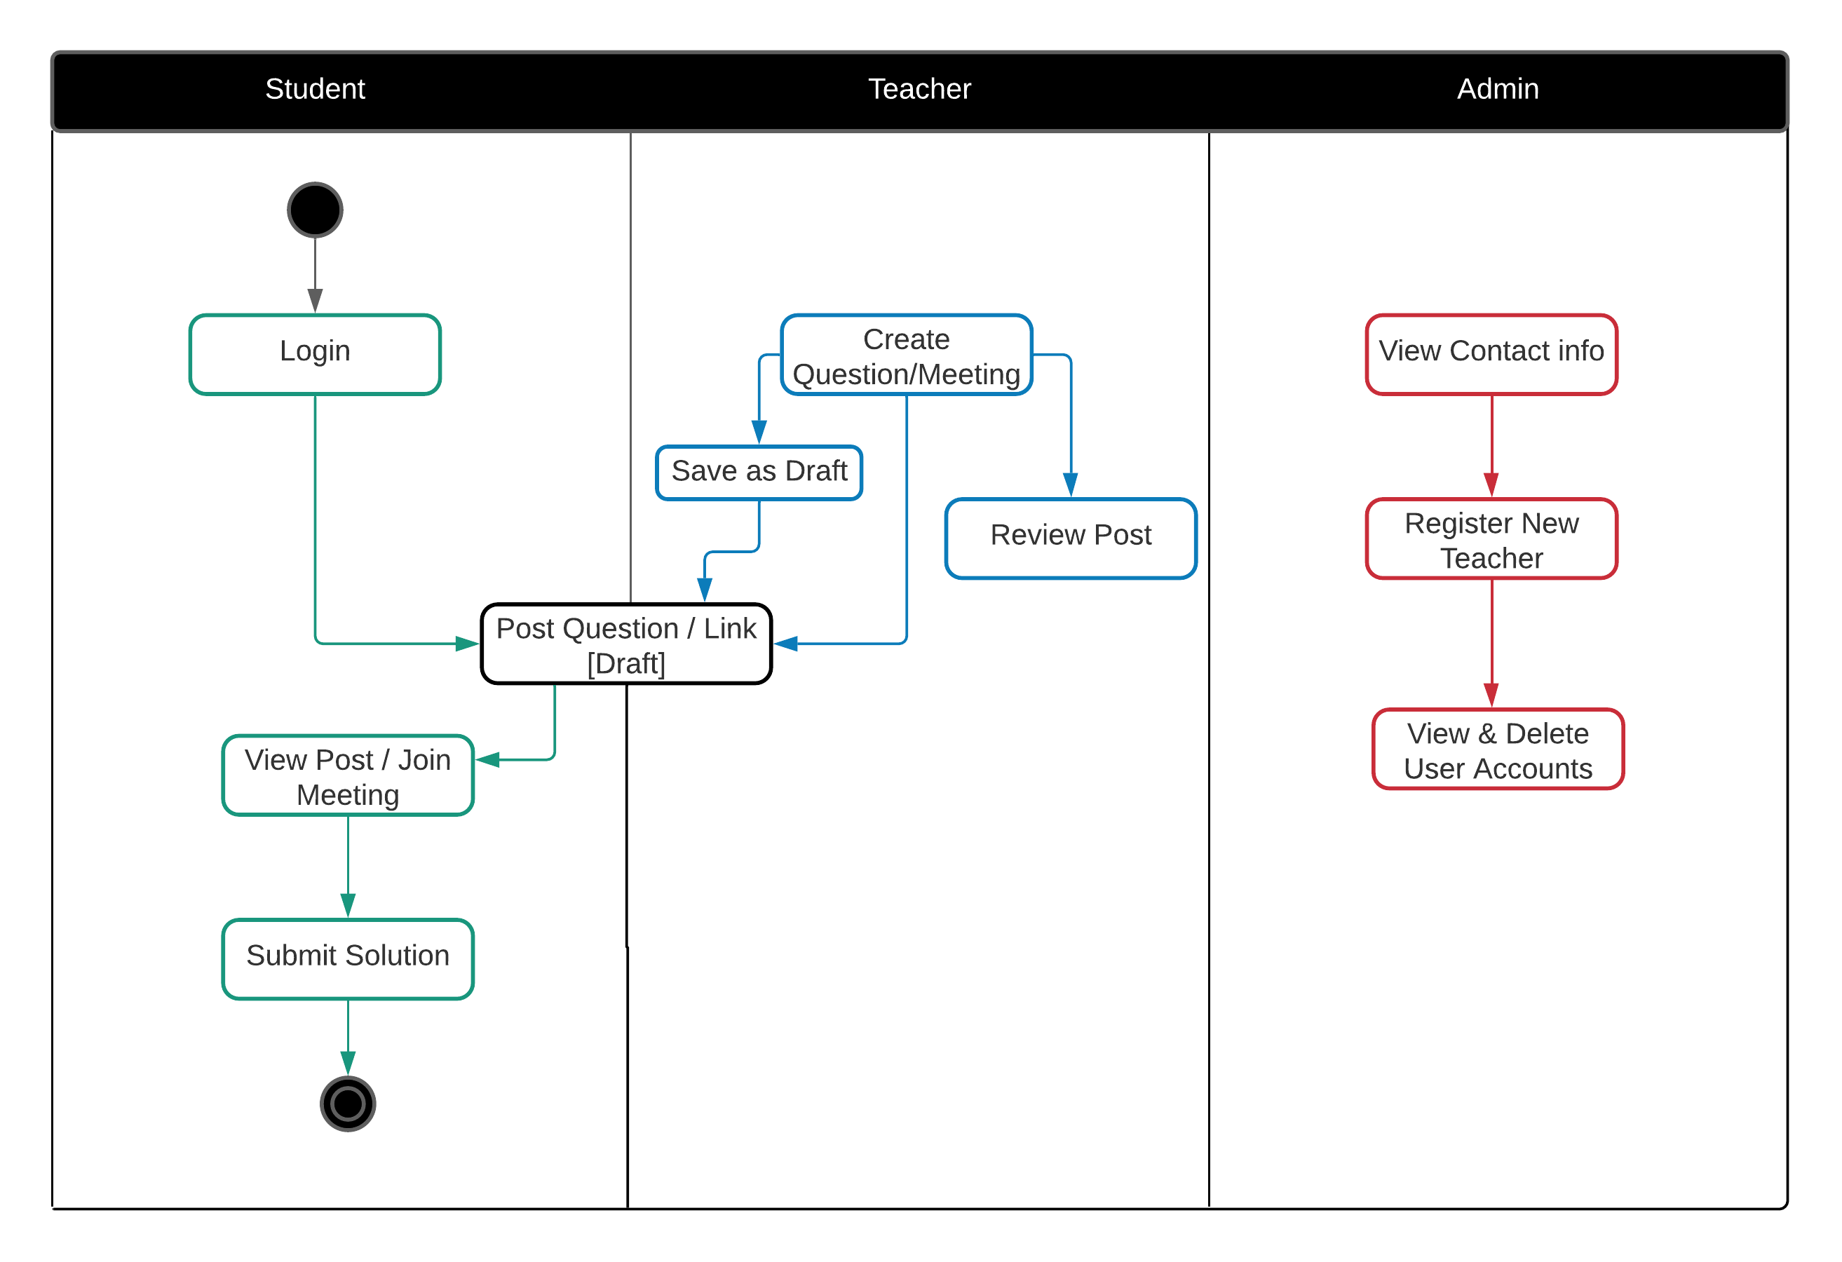

**Figure 3:** Activity Diagram for LU Exam Hive

### 5.1.3 System Sequence Diagrams (LU Exam Hive)

A system sequence diagram is a type of sequence diagram in UML. These charts show the details of events that are generated by actors from outside the system.

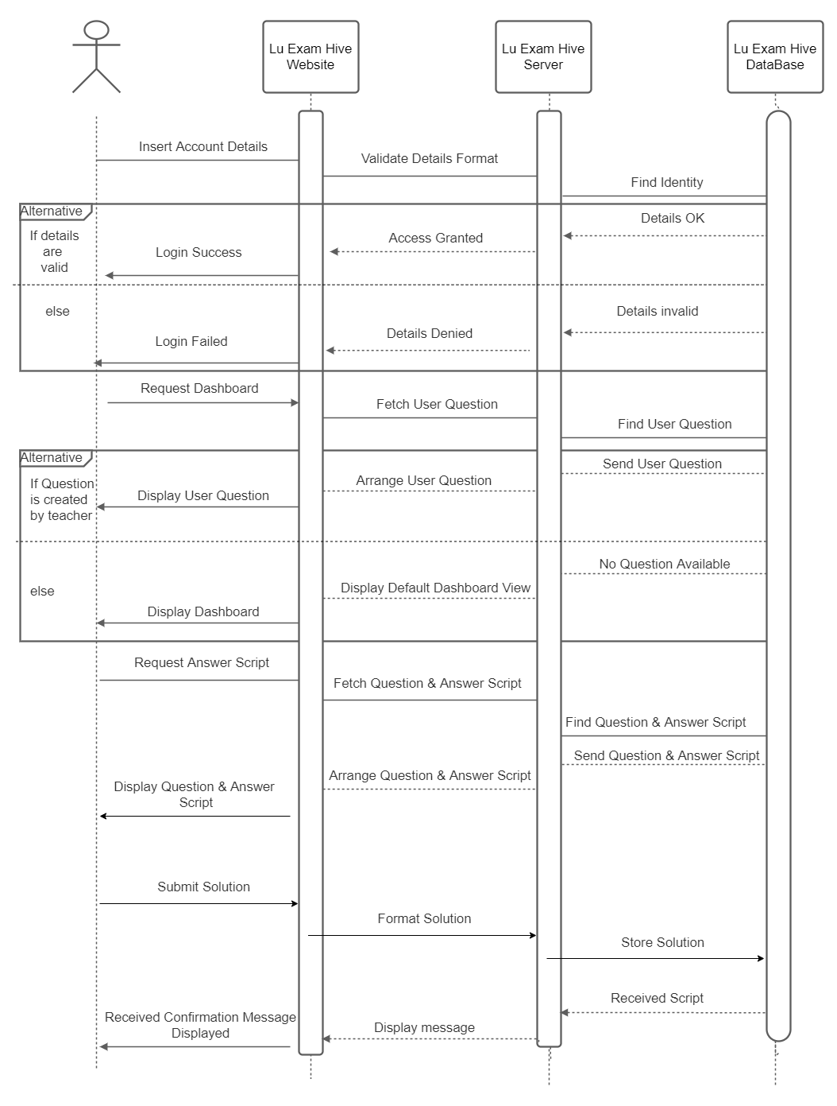

**Figure 4:** Sequence Diagrams for LU Exam Hive

### 5.1.4 Class Diagram (LU Exam Hive)

Class diagrams are the foundation for all other UML structure diagrams. Class diagrams are the main building block of any object-oriented solution. It shows the classes in a system, attributes, and operations of each class and the relationship between each class.

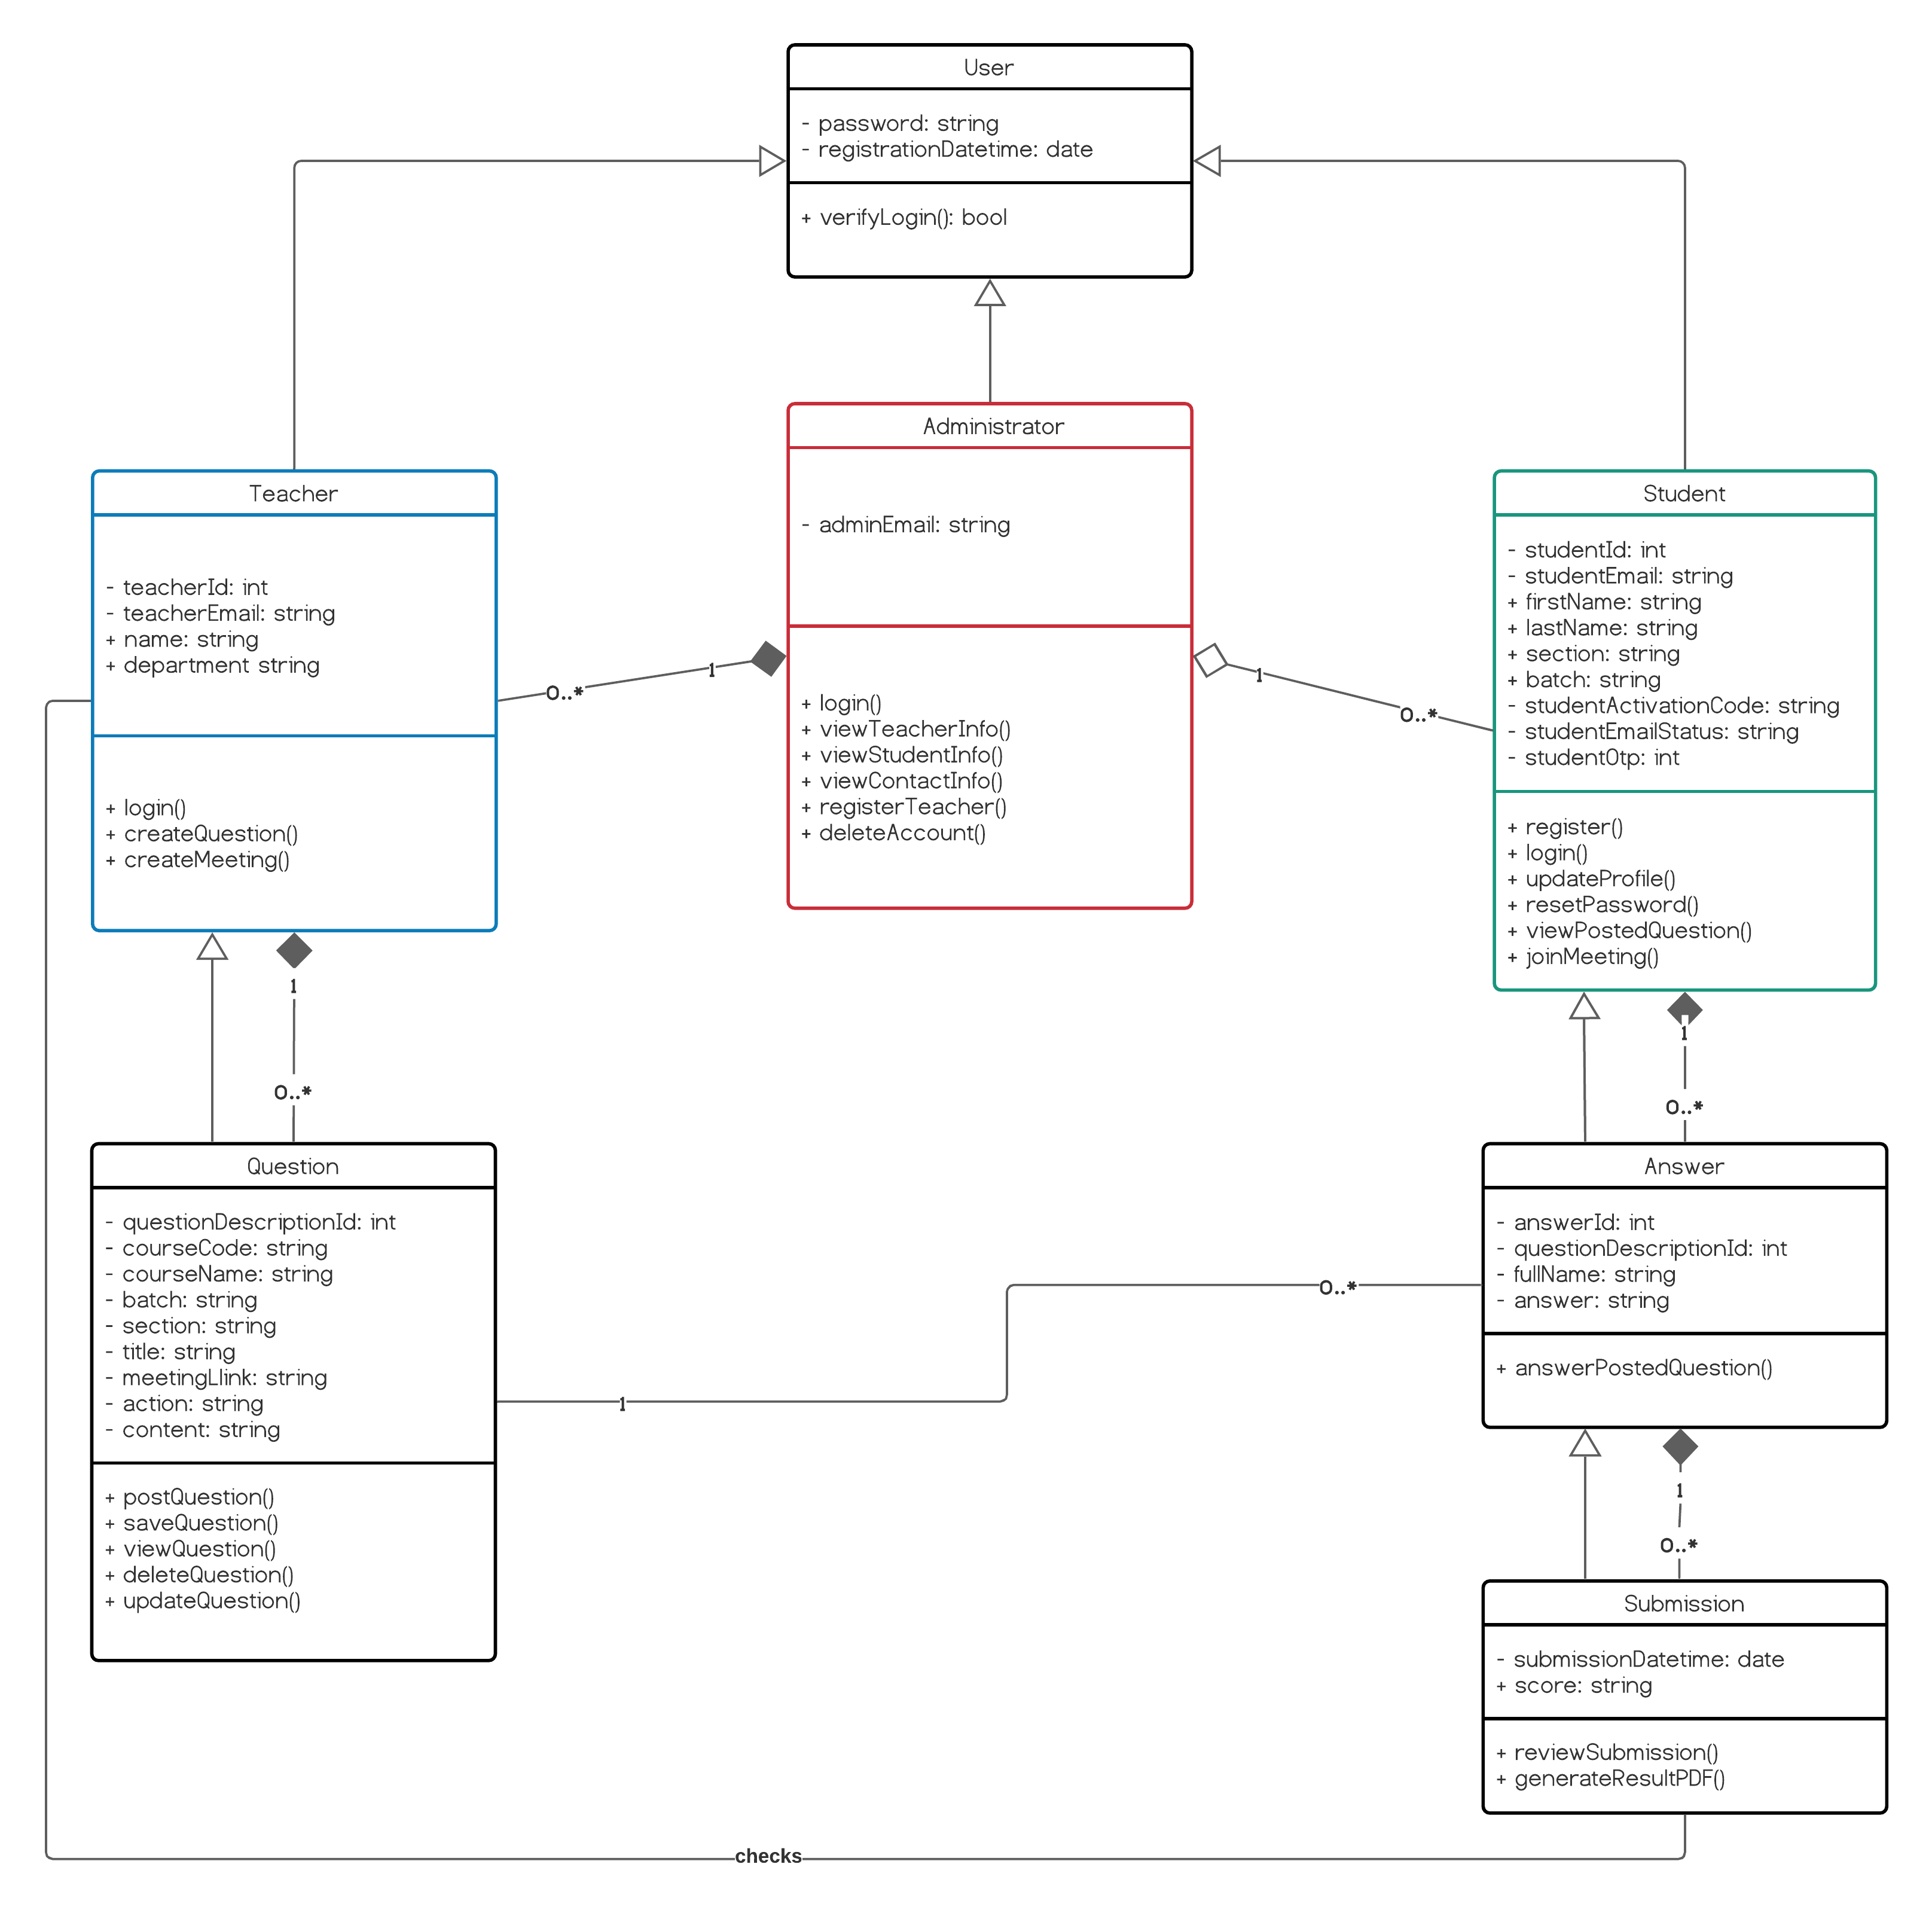**Figure 5:** Class Diagram for Lu Exam Hive

## 5.2 Database Design

Database Design is a collection of processes that facilitate the designing, development, implementation and maintenance of enterprise data management systems. Properly designed databases are easy to maintain, improves data consistency and are cost effective in terms of disk storage space. The database designer decides how the data elements correlate and what data must be stored. The main objectives of database designing are to produce logical and physical designs models of the proposed database system.

The logical model concentrates on the data requirements and the data to be stored independent of physical considerations. It does not concern itself with how the data will be stored or where it will be stored physically. The physical data design model involves translating the logical design of the database onto physical media using hardware resources and software systems such as database management systems (DBMS).

There are two types of Database Techniques:

* Normalization
* ER Modeling

**Normalization:**

Normalization is a database design technique that reduces data redundancy and eliminates undesirable characteristics like Insertion, Update and Deletion Anomalies. Normalization rules divides larger tables into smaller tables and links them using relationships. The purpose of Normalization in SQL is to eliminate redundant (repetitive) data and ensure data is stored logically.

**ER-Diagram:**

An Entity Relationship (ER) Diagram is a type of flowchart that illustrates how “entities” such as people, objects or concepts relate to each other within a system. ER Diagrams are most often used to design or debug relational databases. Also known as ERDs or ER Models, they use a defined set of symbols such as rectangles, diamonds, ovals and connecting lines to depict the interconnectedness of entities, relationships and their attributes. They mirror grammatical structure, with entities as nouns and relationships as verbs.

### 5.2.1 ER-Diagram (LU Exam Hive)

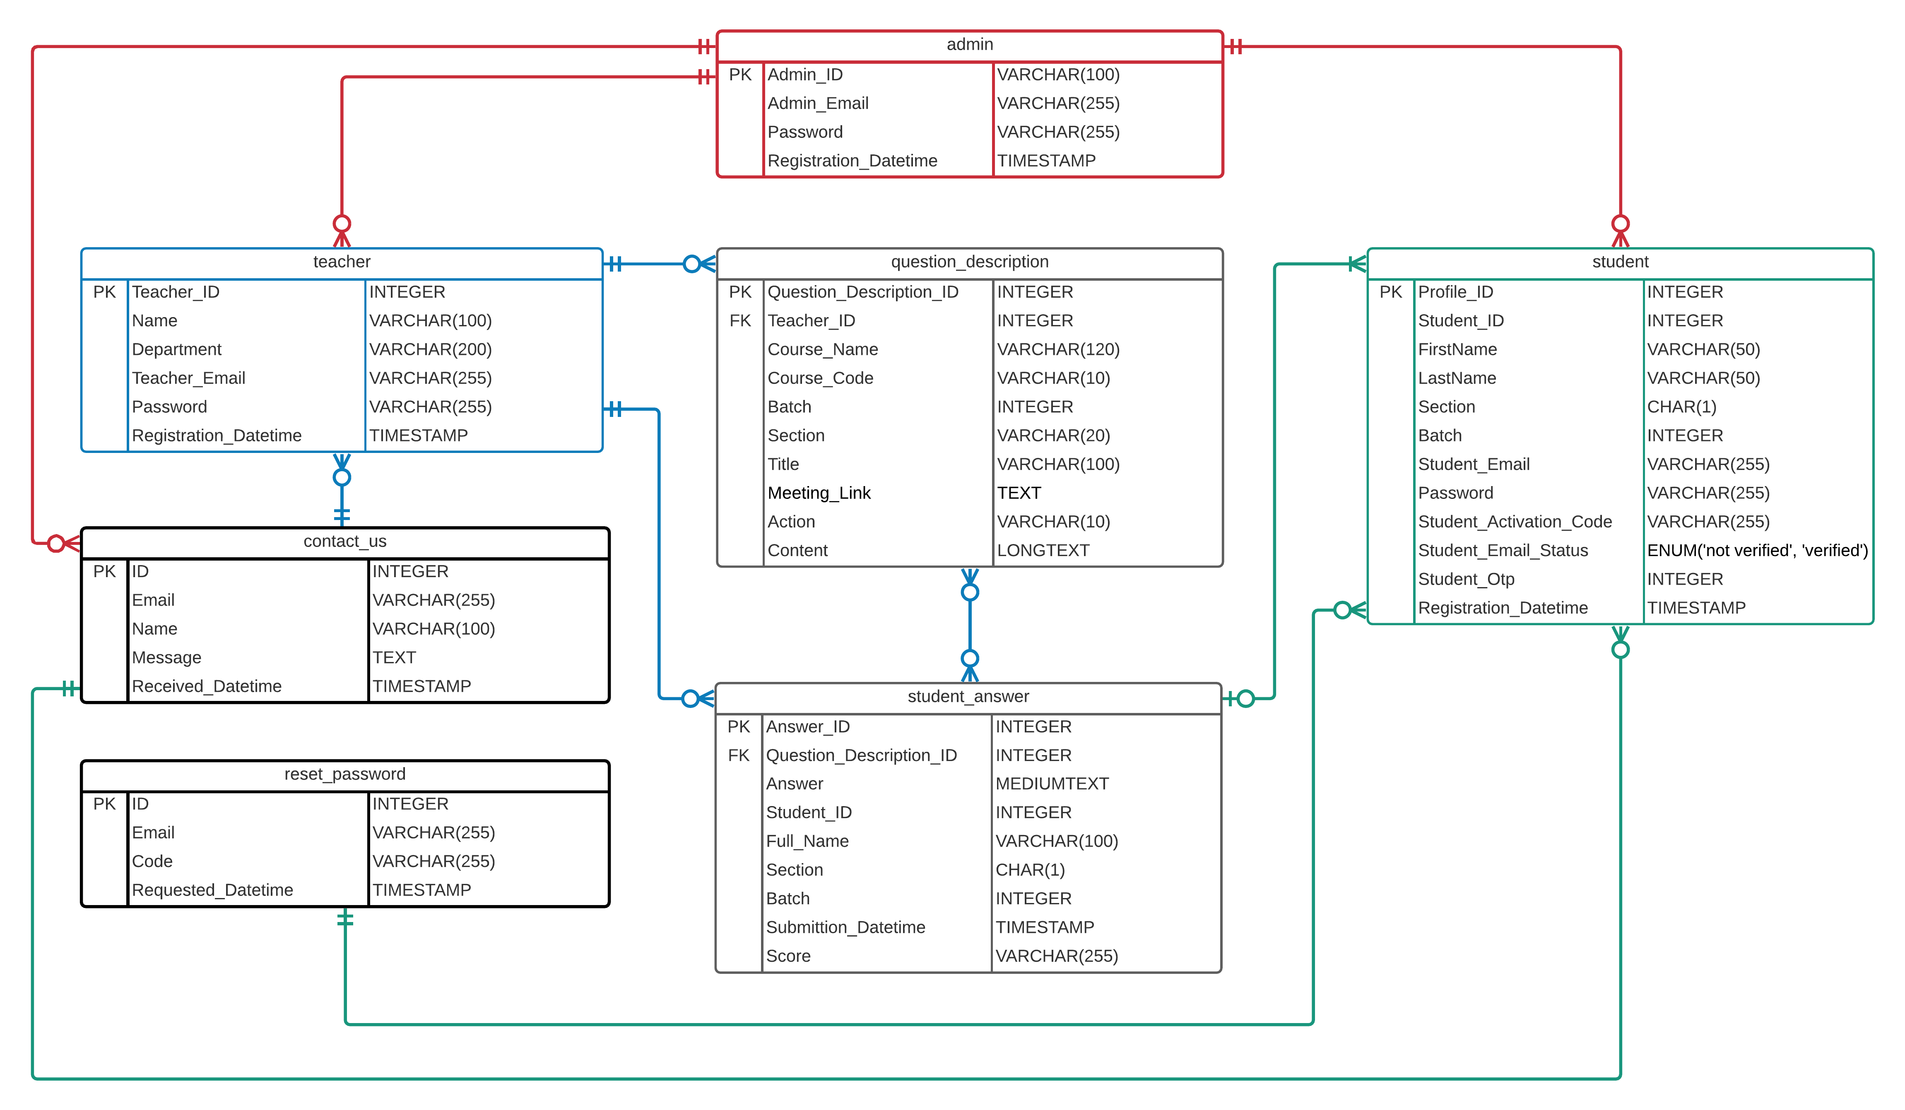

**Figure 6:** ER Diagram for Lu Exam Hive

# Chapter – 6

# Software & Other Tool Requirement

It requires a number of tools like programming language, scripting language, markup language, and some software to write the programs, host a server locally, etc. In this chapter; the software, tools, and other components that are used to construct the LU Exam Hive website are discussed.

## 6.1 XAMPP

XAMPP is an open-source software distribution that provides a local server to host a website directly from your local machine or computer, database, command-line executables, and other modules.

We used XAMPP version 8.0.0 for windows that comes with Apache web server, phpMyAdmin MySQL database, Php as command-line executable.

## 6.2 HTML5

Hypertext Markup Language (HTML) is the standard markup language for documents designed to be displayed in a web browser. It is a system that allows the modification of the appearance of web pages, as well as making adjustments to their appearance. It also used to structure and present content for the web. HTML5 is the latest version of HTML. We used HTML5 to mark up the web page components of LU Exam Hive.

## 6.3 CSS3

Cascading Style Sheets (CSS) is a style sheet language used for describing the presentation of a document written in a markup language such as HTML. While HTML is used to structure a web document defining things like headlines and paragraphs, and allowing you to embed images, video, and other media, CSS comes through and specifies your document’s style like page layouts, colors, and fonts are all determined with CSS.

Essentially, we used Bootstrap which is a CSS framework, to style the markup of LU Exam Hive.

## 6.4 Bootstrap 4.6

Bootstrap is the most popular CSS Framework for developing responsive websites. It is a free and open-source CSS framework directed at responsive, mobile-first front-end web development. It contains CSS- and (optionally) JavaScript-based design templates for typography, forms, buttons, navigation, and other interface components. At the time of building LU Exam Hive, Bootstrap version 4.6 was the stable version. And we integrated it in our website.

## 6.5 JavaScript

JavaScript is a dynamic computer programming language. It is lightweight and most commonly used as a part of web pages, whose implementations allow client-side script to interact with the user and make dynamic pages. It is an interpreted programming language with object-oriented capabilities.

JavaScript is:

* Light Weight Scripting language
* Dynamic Typing
* Object-oriented programming support
* Functional Style
* Platform Independent
* Prototype-based
* Interpreted Language
* Async Processing
* Client-Side Validation
* More control in the browser

The JavaScript code is executed on the user’s processor instead of the web server thus it saves bandwidth and load on the web server. Any JavaScript-enabled browser can understand and interpret JavaScript code. Any JavaScript code can be executed on different types of hardware a JavaScript program written for. It encompasses all the capabilities of a procedural language. Branching, looping, condition checking are some of those capabilities that can be executed on a web page.

It has a number of plugins and libraries available to make JavaScript simpler. jQuery is one of them. Bootstrap 4.6 uses the jQuery plugin.

## 6.6 jQuery

jQuery is a JavaScript library designed to simplify HTML DOM tree traversal and manipulation, as well as event handling, CSS animation. The main purpose of jQuery is to provide an easy way to use JavaScript on website to make it more interactive and attractive. It is also used to add animation.

Its features include:

* HTML manipulation
* DOM manipulation
* DOM element selection
* CSS manipulation
* Effects and Animations
* Utilities
* AJAX
* HTML event methods
* JSON Parsing
* Extensibility through plug-ins

Bootstrap 4.6 behind the scene uses jQuery. Bootstrap uses jQuery for JavaScript plugins like modals, tooltips, etc. To make this work with Bootstrap, the jQuery CDN is added in the project files. LU Exam Hive has some Bootstrap components that works with jQuery but we didn’t have to write the jQuery codes as it is already working behind the scene when we include the particular component or utilities of Bootstrap.

## 6.7 PHP

PHP is a server-side scripting language. that is used to develop Static websites or Dynamic websites or Web applications. PHP stands for Hypertext Pre-processor, which earlier stood for Personal Home Pages. PHP scripts can only be interpreted on a server that has PHP installed. The client computers accessing the PHP scripts require a web browser only. PHP is well suited for web development and can be embedded into HTML. It is most popular and frequently used worldwide scripting language, the main reason of popularity is; It is open source and very simple. PHP is:

* Very simple, compared to other scripting languages.
* PHP is an interpreted language. So, there is no need for compilation.
* PHP is faster than other scripting languages like ASP and JSP.
* It is open-source, meaning one does not have to pay to use PHP.
* PHP is platform-independent. it will run on every platform.
* PHP has some predefined error reporting constants that are very useful while debugging.
* PHP supports variable usage without declaring its data type. It will be taken at the time of the execution based on the type of data it has on its value.
* PHP has inbuilt support for working hand in hand with MySQL database management systems and it also can be used with other database management systems like Postgres, Oracle, etc.

The PHP that comes with our version of XAMPP is PHP 8.0 which is the latest version of PHP that more reliable and comes with some new features.

A PHP file can be identified with the .php file extension. An example of the basic syntax of PHP code is given below:

<?php

  echo "Hello World";

?>

As PHP is well suited for website development and it can be embedded into HTML. It is easier to maintain the web page markup; HTML codes, and the required PHP script of that web page in the same document instead of creating separate document files for HTML and PHP code. Both can be embedded in the same file that is a PHP file with .php extension.

All of the web view document files of LU Exam Hive that are PHP files that contains both of the page markups and php scripts.

## 6.8 MySQL

LU Exam Hive is a web-based online examination system that will have a lot of data to deal with. For that, we have DBMS or database management system. LUEH used to the MySQL DBMS. MySQL is an open-source relational database management system (RDBMS). A relational database organizes data into one or more data tables in which data types may be related to each other; these relations help structure the data.

**SQL:**

SQL is a language programmer use to create, modify and extract data from the relational database, as well as control user access to the database. In addition to relational databases and SQL, an RDBMS like MySQL works with an operating system to implement a relational database in a computer's storage system, manages users, allows for network access and facilitates testing database integrity and creation of backups.

MySQL is free and open-source software under the terms of the GNU General Public License and is also available under a variety of proprietary licenses. It has stand-alone clients that allow users to interact directly with a MySQL database using SQL, but more often MySQL is used with other programs to implement applications that need relational database capability.

Reasons for using MySQL:

* MySQL consists of a solid data security layer that protects sensitive data from intruders. Also, passwords are encrypted in MySQL. Although we used other password techniques to encrypt passwords for more security.
* It follows the working of a client/server architecture. There is a database server (MySQL) and arbitrarily many clients (application programs), which communicate with the server; that is, they can query data, save changes, etc.
* It is considered as one of the very fast database languages, backed by a large number of the benchmark test.
* MySQL allows transactions to be rolled back, commit, and crash recovery.
* Provides a unified visual database graphical user interface tool. We can access the MySQL GUI by starting the MySQL module on the XAMPP software.
* MySQL is faster, more reliable, and cheaper because of its unique storage engine architecture.
* MySQL is free and comes with the XAMPP software.
* It provides very high-performance results in comparison to other databases without losing an essential functionality of the software.
* It has fast loading utilities because of the different cache memory.

PHP works very well with MySQL. LU Exam Hive used MySQL that comes with XAMPP 8.0.0.

**Storage Engine:**

Storage engines are MySQL components, that can handle the SQL operations for different table types to store and manage information in a database. LU Exam Hive database management system used the InnoDB storage engine. InnoDB is mostly used general-purpose storage engine. InnoDB is a robust storage engine that offers:

* Full ACID compliance.
* Commit, rollback, and crash-recovery.
* Row-level locking.
* FOREIGN KEY referential-integrit­y constraints.
* Increase multi-user concurrency (via non-locking reads).

With the above functionality that InnoDB offers, it is obvious why it is the default MySQL engine. It is an engine that performs well and offers many of the required attributes that any database would need.

## 6.9 Apache

Apache is a free and open-source cross-platform web server software. It is a powerful Web server program with features that compare to its high-priced competitors. The software includes an administration control panel, customizable error messages, and authentication schemes. The virtual hosting module allows you to run multiple websites from the same server. The resources for Apache are available on multiple websites around the world. This allows server owners to access reference articles and live help whenever necessary. This gives Apache a major advantage over programs that only have a company website as a source of support. When a new bug is found, the open-source user community typically creates a patch to fix it and posts the solution for free on forums and social media websites.

LU Exam Hive uses Apache web server that comes with XAMPP software. This XAMPP Apache server gives a suitable environment for testing MYSQL, PHP, and Perl projects on the local computer. During the building process of LU Exam Hive, we constantly used it to test the website in our local computer server. And we used Apache as server, it will be easy to transfer the website in a live Apache web server after the completion of the LU Exam Hive project.

Reasons for using Apache:

* Compatible with PHP.
* Loadable dynamic modules.
* Handling of static files.
* Auto-indexing.
* Supports HTTP/2.
* FTP connections, etc.

## 6.10 Git & GitHub

**Git:**

Git is software for tracking changes in any set of files, usually used for coordinating work among programmers collaboratively developing source code during software development. Its goals include speed, data integrity, and support for distributed, non-linear workflows. It is the most commonly used version control system. Git tracks the changes that are made in files, so the user has a record of what has been done, and the user can revert to specific versions it they ever need to. Git also makes collaboration easier, allowing changes by multiple people to all be merged into one source. Git software runs locally. Users’ files and their history are stored on their computer. Users can also use online hosts such as GitHub or Bitbucket to store a copy of the files and their revision history.

**GitHub:**

GitHub is a cloud-based project management and organization platform that incorporates Git’s version control features. Meaning, all GitHub users can track and manage changes being made to the source code in real-time while having access to all of the other Git functions available to them at the same place.

GitHub essentials are:

* Repositories
* Branches
* Commits
* Pull Requests
* Git (the version control software GitHub is built on)

GitHub can be used for free and it requires payment for some advanced features. But the free version is the overall package that is used by many developers.

**GitHub Desktop:**

GitHub Desktop is a software that provides a graphical user interface to interact with GitHub from the desktop. Instead of typing commands in GitHub CLI, GitHub desktop can be used which saves time and easy to interact with.

GitHub Desktop supports:

* Attributing commits with collaborators.
* Checkout branches with pull requests.
* Push to your remote Git repositories.
* Syntax highlighted diffs.
* And almost everything that GitHub can offer.

We used GitHub to keep track of our project work and GitHub desktop to interact with GitHub cloud instead of depending on the browser. And as we had to go through the pandemic situation and team members could not conduct any meeting together being physically in a place, GitHub helped to monitor our works and if anything went wrong, we could easily revert back to a previous version of the project.

## 6.11 PHPMailer

PHPMailer is an open-source PHP library to send emails with. It is a way of sending emails programmatically with PHP. Sending emails directly by PHP code requires a high-level familiarity to SMTP standard protocol and related issues and vulnerabilities about Email injection for spamming. PHPMailer is one of the popular solutions for these matters on PHP.

Some of features PHPMailer include:

* Plain text, HTML and multipart batched files.
* SSL and TLS (Secure Sockets Layer and Transport Layer Security).
* SMTP, Qmail, POP3.
* Debugging system.
* PHP sendmail and mail methods.

We integrated PHPMailer in LUEH in order to achieve the functionality of sending OTP verification code during student registration automatically to verify their email. Also, to send reset password link automatically in users email if they request for that from the LUEH website. And to receive emails if someone contacts us using the contact us UI in LUEH.

## 6.12 Summernote

Summernote is a JavaScript library that helps to create WYSIWYG editors online. Summernote can embed into any website to create a WYSIWYG editor by the CDN or downloading the files directly.

Summernote has a few special features:

* Paste images from clipboard
* Saves images directly in the content of the field using base64 encoding, so you don't need to implement image handling at all
* Simple UI
* Interactive WYSIWYG editing
* Handy integration with server
* Supports Bootstrap 3 and 4 integrities
* Lots of plugins and connectors provided together

For creating questions in LU Exam Hive online examination system, we have embedded Summernote that will provide the teacher users to format the question page just like any other word program like MS Word.

## 6.13 FPDF

FPDF is a PHP class which allows to generate PDF files with pure PHP. So, essentially it is PHP library that allows to generate PDF files. F from FPDF stands for Free. We have added FPDF in LUEH to generate the exam results in PDF document.

## 6.14 Visual Studio Code

It requires a text editor to write code on. We mainly used Visual Studio Code to write the required script and codes for LUEH. Visual Studio Code is a free open-source text editor by Microsoft. It has support for development operations like debugging, task running, and version control. One of the main reasons for using VS Code is because of the git integration. It keeps track of which file is being modified. The VS Code user interface allows for a lot of interaction compared to other text editors. To simplify user experience, VS Code is divided into five main regions:

1. The activity bar
2. The side bar
3. Editor groups
4. The panel
5. The status bar

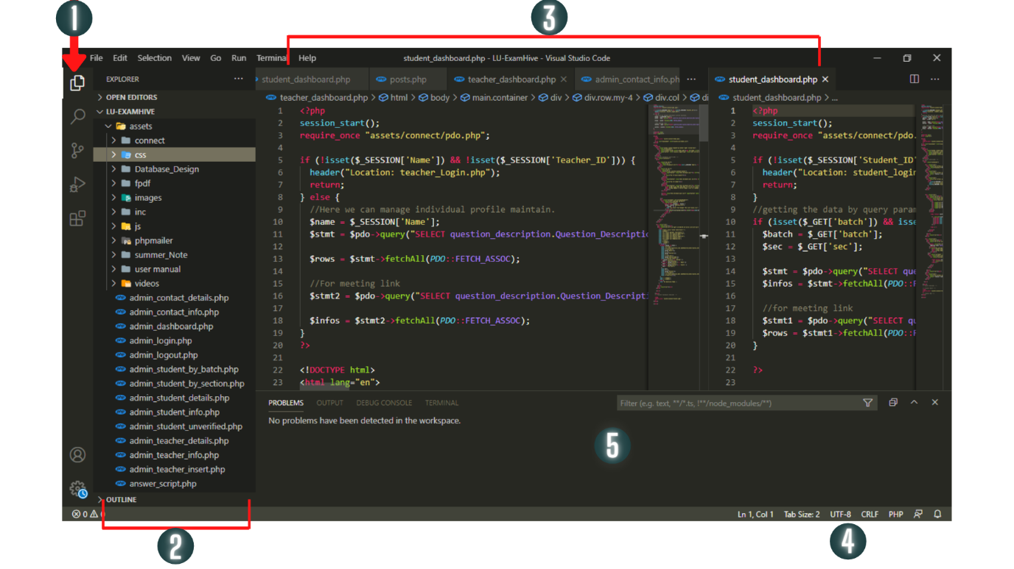

**Figure 8:** The VS Code Interface

## 6.15 Browsers and others

Web browsers are essentials in web development to debug, view the web pages during development. Browser like Firefox has DevTools and inspect mode which are very helpful in web development. We used Chrome and Firefox mostly used in our project. Besides, we constantly checked the LUEH website on Microsoft EDGE and Opera browser too.

# Chapter – 7

# Evaluation

This chapter presents evaluation of the project including platform evaluation, functional evaluation and non-functional evaluation.

## 7.1 Platform Evaluation

The project mainly deals with the web based Online Examination System. We tried to evaluate the idea of having an Online Exam System for our own university. There are some other such kind of system can be found in the internet. But not every system is capable of doing what we wanted to do. For instance- in some website we can create question and publish it to the students via another platform, not only this if we want to arrange a meeting we need to go and use another special platform. So, all together it’s a kind of mess to use all the different platform. It would be easier and user friendly if we could find a solution of having all kinds of necessary functionalities together in one platform. And that was our idea to make this LU Exam Hive where we can have the desire functionalities together at a time. We tried to make it more attractive and user-friendly themes are included for the end user. Most importantly we think it as our own university product which can be used for taking online exam by the teacher of Leading University when necessary.

## 7.2 General Functional Evaluation

Next, here we will provide a general functional evaluation. We tested each functional requirement. There is the table below showing result of the test.

**Functional Requirements in tabular form:**

|  |  |  |
| --- | --- | --- |
| **ID** | **Requirement** | **Fulfilled?** |
| **1.** | Teacher can have his/her own dashboard | Yes |
| **2.** | Teacher can create new question | Yes |
| **3.** | Teacher can arrange meeting | Yes |
| **4.** | Teacher can save a created question | Yes |
| **5.** | Teacher can post a question | Yes |
| **6.** | Teacher can edit or delete the question which is drafted | Yes |
| **7.** | Teacher can see all the posted question | Yes |
| **8.** | Teacher can see and download the result as pdf format | Yes |
| **9.** | Dynamic question creation | Yes, but not functional for the student users. |
| **10.** | Student can register and have the login and logout functionalities | Yes |
| **11.** | Student can change the password by using forgot password option | Yes |
| **12.** | Student can login to his own dashboard | Yes |
| **13.** | A Student can see the all the posted question by the respective teacher | Yes |
| **14.** | A Student can see only meeting link created for his/her section | Yes |
| **15.** | Students can Join the meeting scheduled by the teacher through the meeting link shown | Yes |
| **16.** | A Student can answer the posted question via the answer script | Yes |
| **17.** | Answer Script Clock working | Yes |
| **18.** | Admin can monitor and edit all the student and teacher list | Yes |
| **19.** | Admin can insert a new teacher to the database | Yes |
| **20.** | Admin can delete a teacher or student record | Yes |
| **21.** | Admin can sort the verified and unverified student list | Yes |
| **22.** | Admin can search any student by ID and have the details of that student | Yes |

## 7.3 Non-Functional Evaluation

### 7.3.1 Flexibility

The website is flexible to edit and some new functionalities can be added efficiently. Here some functional button can be added in the teacher dashboard if we want to improve the dashboard content. Also, there can be a button called assignment by which a teacher can post an assignment to the student and the code can be added.

The platform is suitable for teacher and students because of its interior design. It is plain and simple also attractive. The website can be accessible from all sort devices like different model of mobile phone also with tablets and with computer. It is fully responsive and functional in different views.

The website is available to use on different kinds of browser which we generally use in our daily life. For instance – Google Chrome, Firefox, Microsoft Edge, Opera and others.

The website loads smoothly from the server and the landing page is operatable very effectively.

### 7.3.2 User Interface

The user interface is simple and attractive. An user can easily interact with the interface. There are some points about user interface given below-

* Fully Responsive in all kinds of device.
* Buttons are designed as the user can easily identify which button it can be by just looking at that button. For example- Delete button is colored as red, save button is in Black.

 

* The are some icons also added to look little different. For example- in login, logout button or in the teacher dashboard edit and delete question function is decorated with the icon.

  

* Admin has a dashboard UI where he/she can monitor or control the website.

More of UI design are given in chapter 8.

# Chapter – 8

# GUI Design

## 8.1 UI Flowcharts

A UI flowchart used to describe the logical relationship between pages. Itis a picture of the separate steps of a process in sequential order.

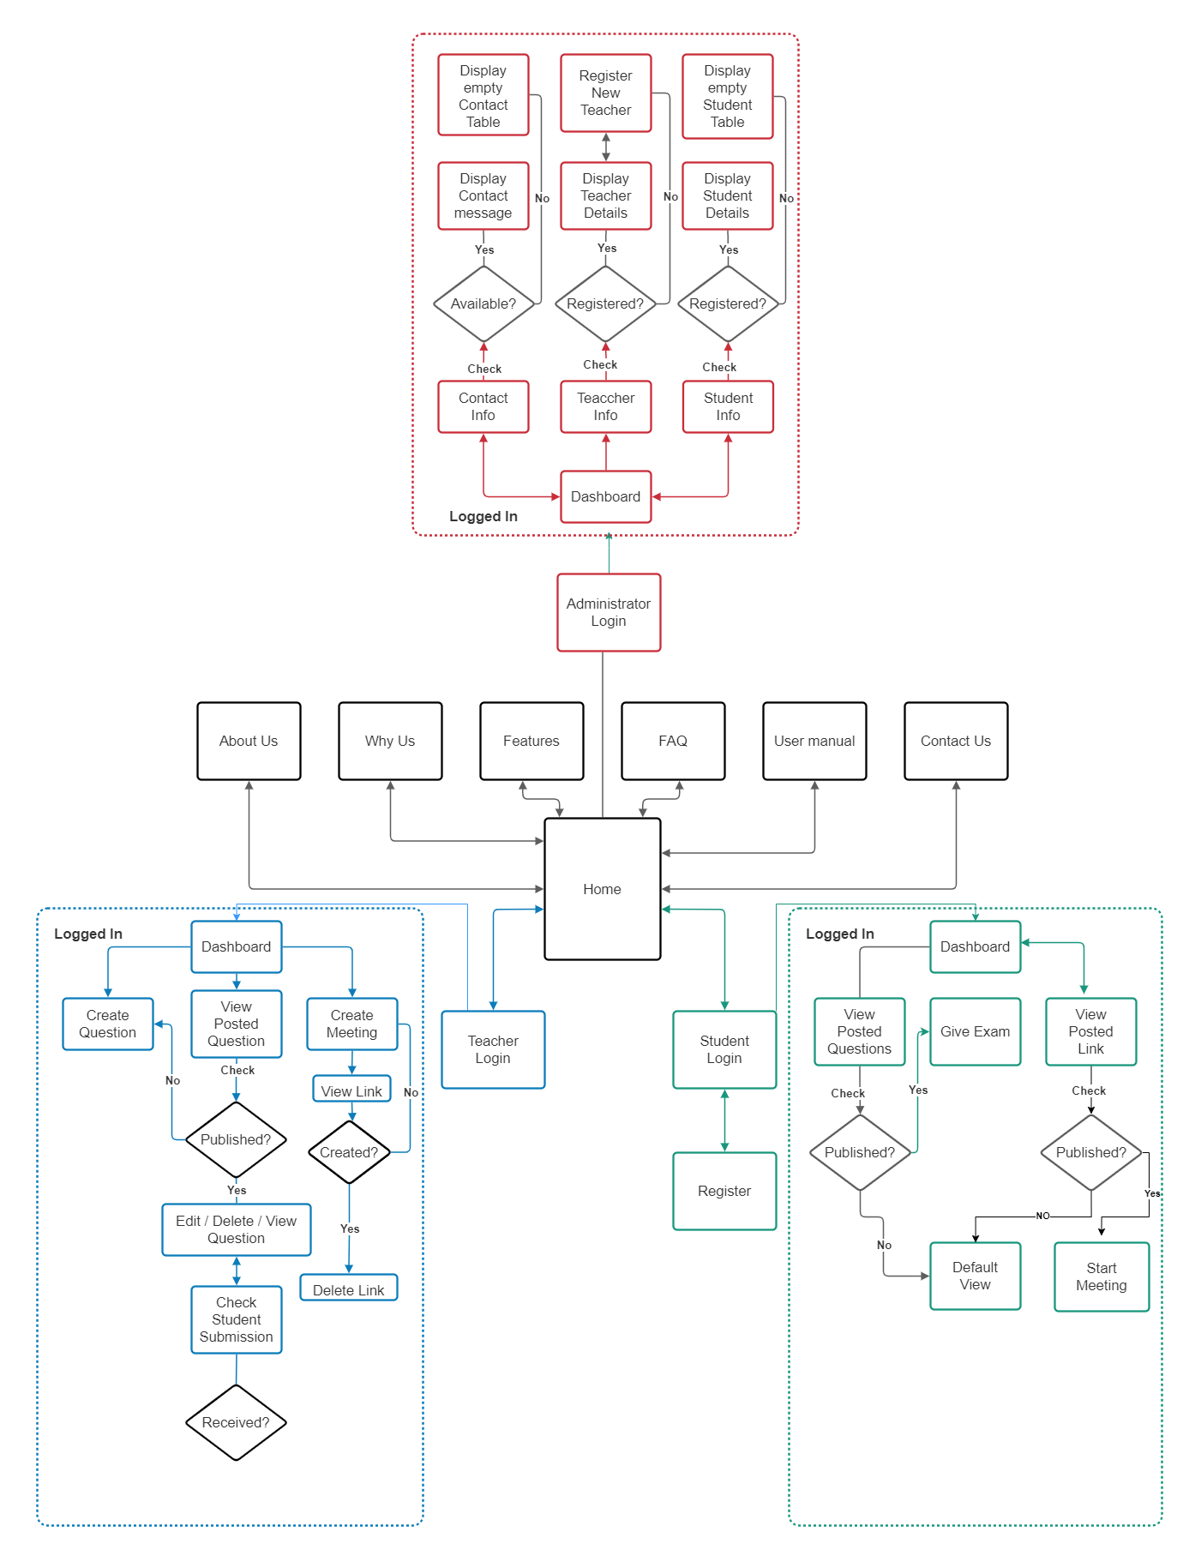

**Figure 8:** UI Flowcharts of LU Exam Hive

## 8.2 UI Design

User interface (UI) design is the process designers use to build interfaces in software or computerized devices, focusing on looks or style. Designers aim to create interfaces which users find easy to use and pleasurable.

Graphical user interfaces (GUIs)—Users interact with visual representations on digital control panels. A computer’s desktop is a GUI.

### 8.2.1 Home View (Users)

Home View has links to most of the key pages of the website and also is the place where messages are conveyed to the users i.e., reasons to use the website, selecting their avatar, tips & life hacks for the students & to whom is this site made for.

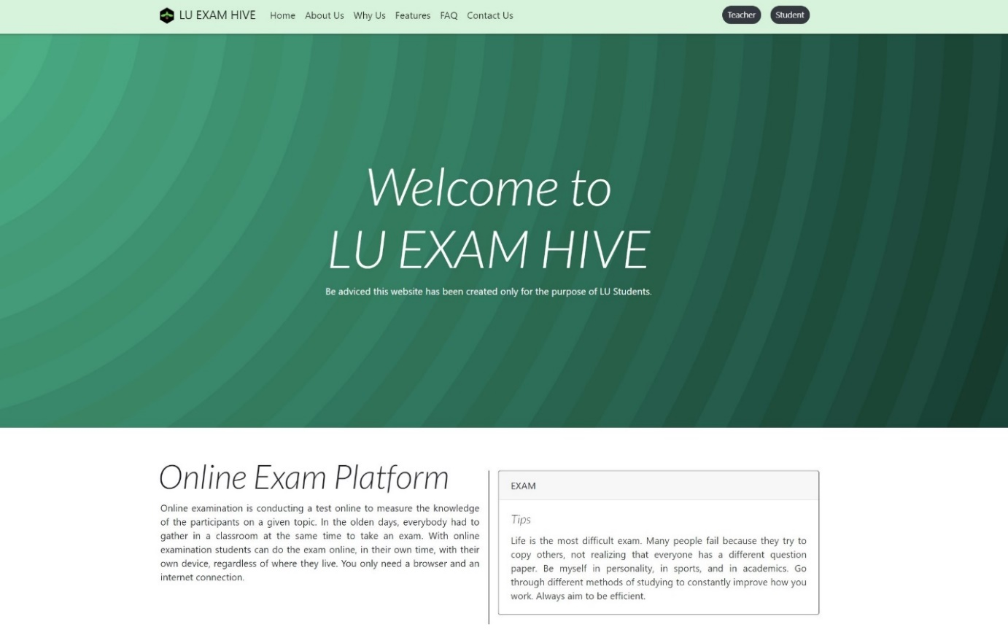

**Figure 9:** Home View of LU Exam Hive

### 8.2.2 About Us (Users)

A short Video of the website mainly showing students how to use the platform.

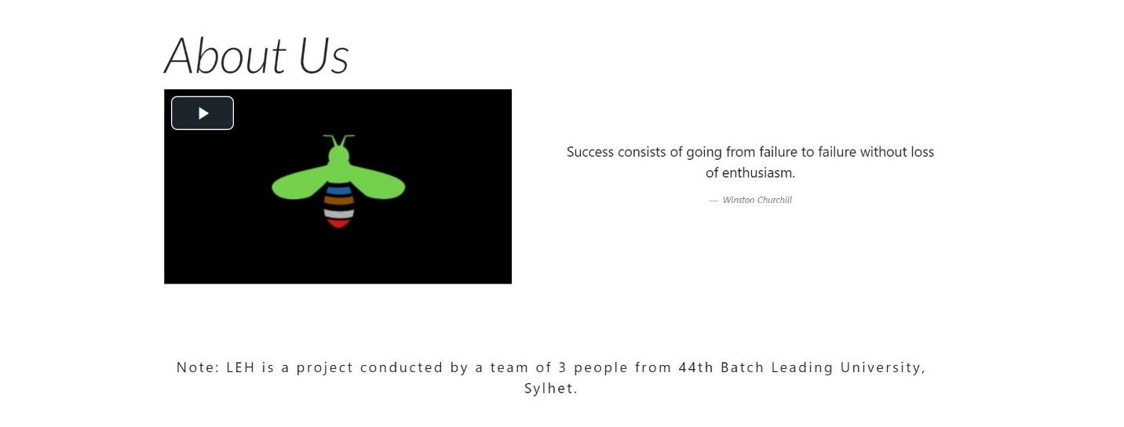

**Figure 10:** About Us of LU Exam Hive

### 8.2.3 Why Exam Hive? (Users)

Key reasons are stated in this section for the users to get onto LU Exam Hive.

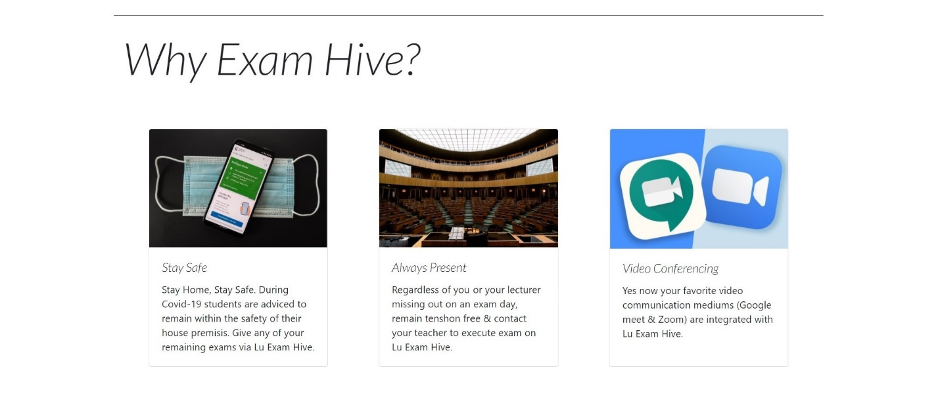

**Figure 11:** Why Exam Hive? of LU Exam Hive

### 8.2.4 Features (Users)

Attractive features of the website are stated in this section to draw attention of the users.

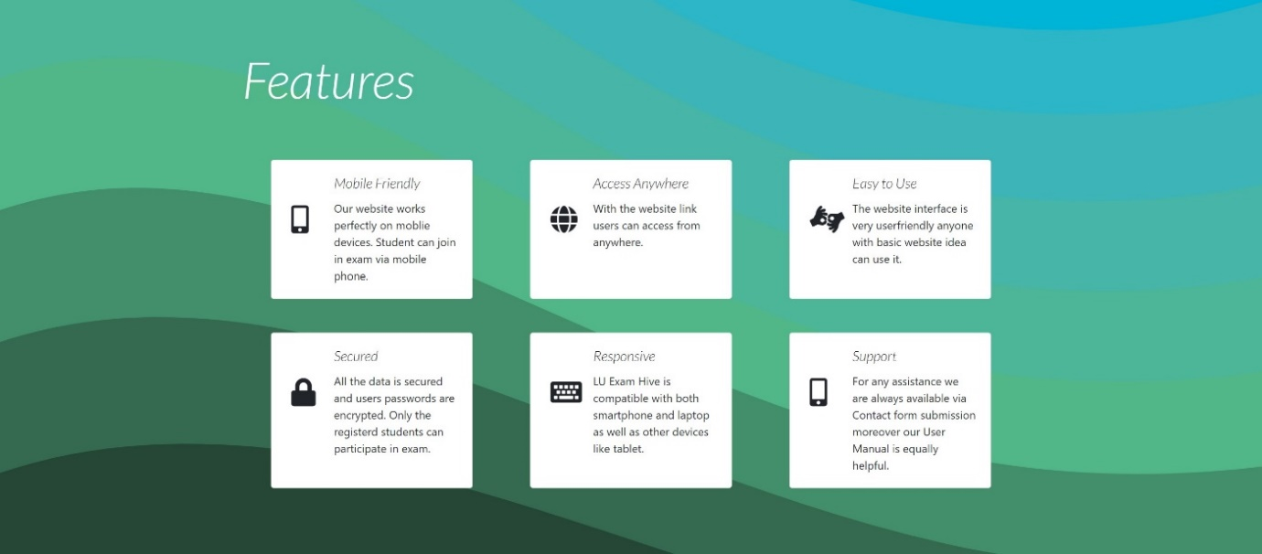

**Figure 12:** Features of LU Exam Hive

### 8.2.5 FAQ (Users)

Quick response to curious & common questions of Users are placed in this section.

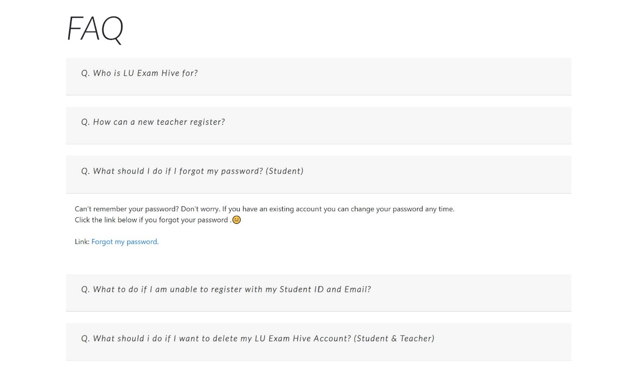

**Figure 13:** FAQ of LU Exam Hive

### 8.2.6 Contact Us (Users)

Users can reach out to us with their query regarding any problem related to the website using Contact Us form which is present in almost every page via link.

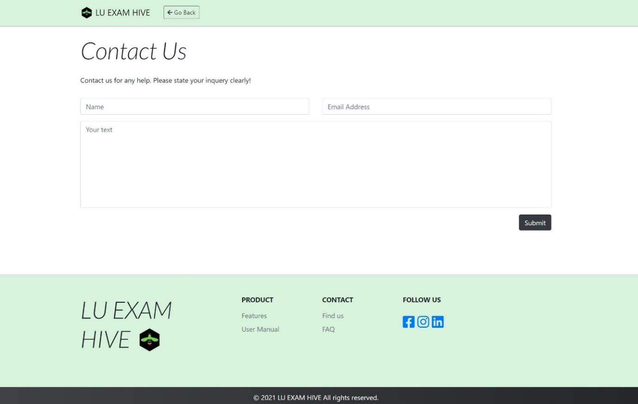

**Figure 14:** Contact Us of LU Exam Hive

### 8.2.7 Login (Teacher)

LU Exam Hive designs UI of Teachers login uniquely which is simple, easy to understand and smooth to use. New teacher will have to reach out to the administrator via contact us form following the procedure provided in the FAQ section to get registered to the site.

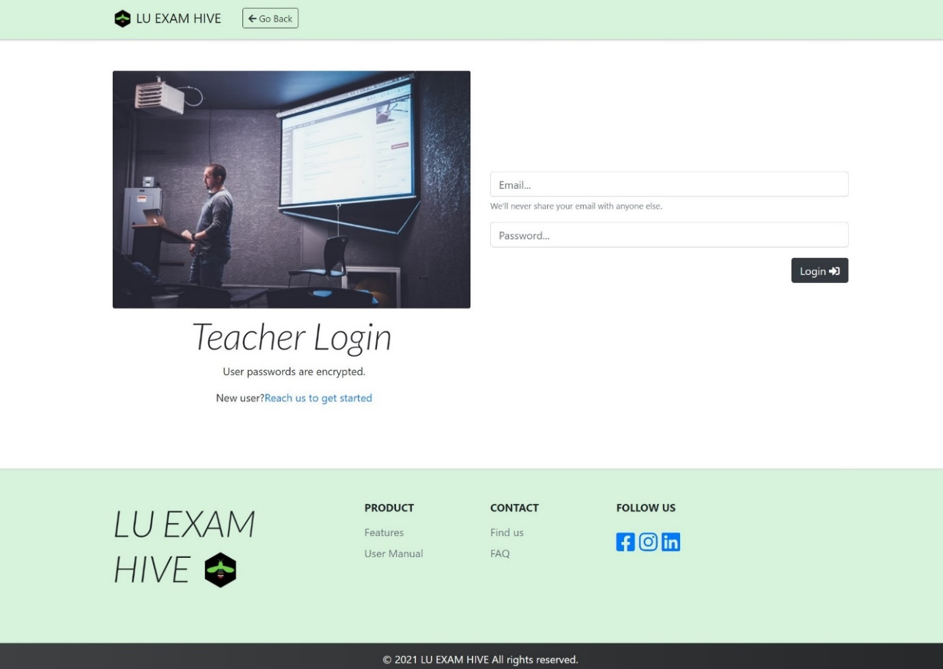

**Figure 15:** Teacher Login of LU Exam Hive

### 8.2.8 Login (Student)

LU Exam Hive understands that all students of a university are not familiar with complex UI thus keeping the accessibility aspect of every student in mind the login interface is designed to be simple, clear and easy to understand.

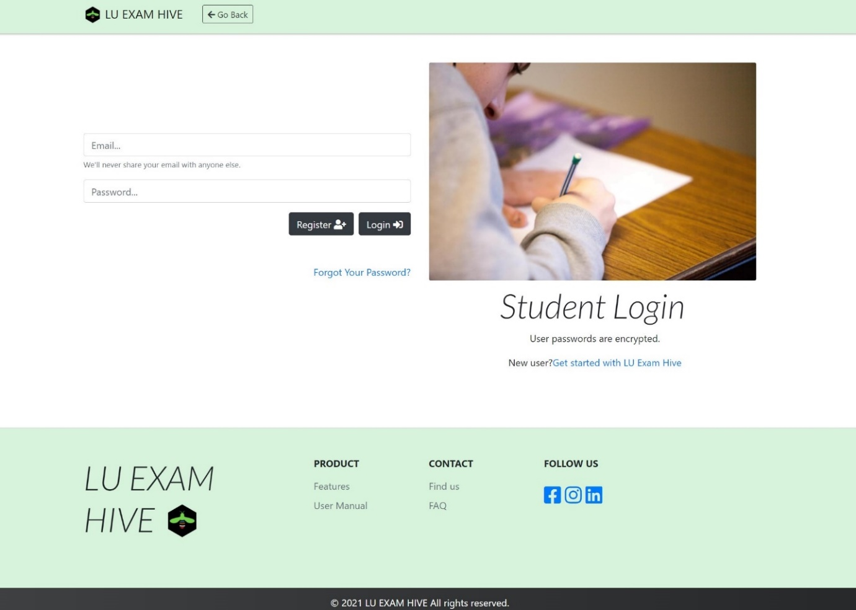

**Figure 16:** Student Login of LU Exam Hive

### 8.2.9 Login (Admin)

Admin login has to be approached via URL using a secret link.

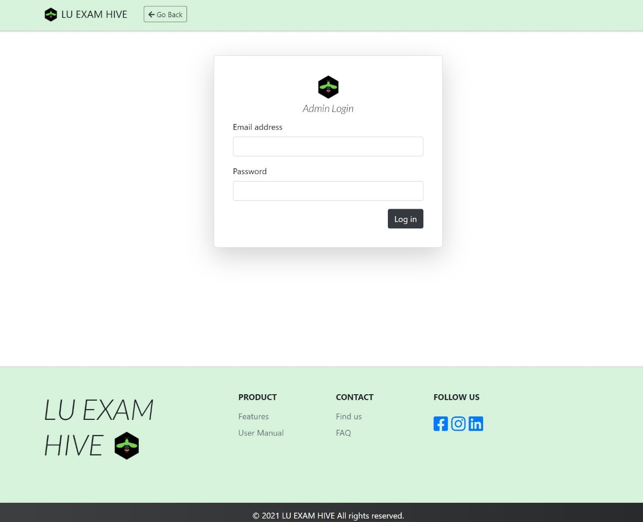

**Figure 17:** Admin Login of LU Exam Hive

### 8.2.10 Registration (Student)

Students of the University will be requested to fill in this form in order to further navigate the pages of LU Exam Hive. After registration an OTP will be sent to user email address for verification.

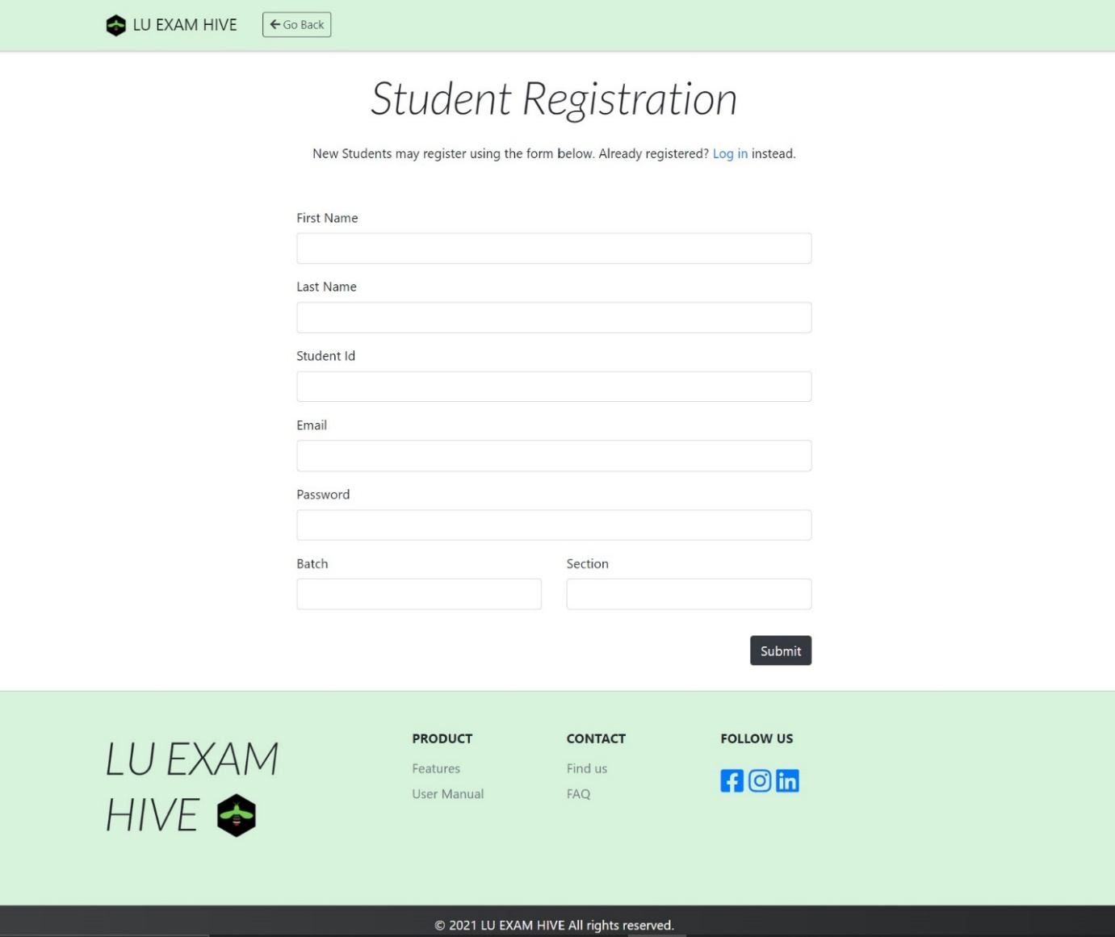

**Figure 18:** Student Registration Form of LU Exam Hive

### 8.2.11 Forgot Password (Student)

We often do forget our passwords thus not to worry, LU Exam Hive has you covered.

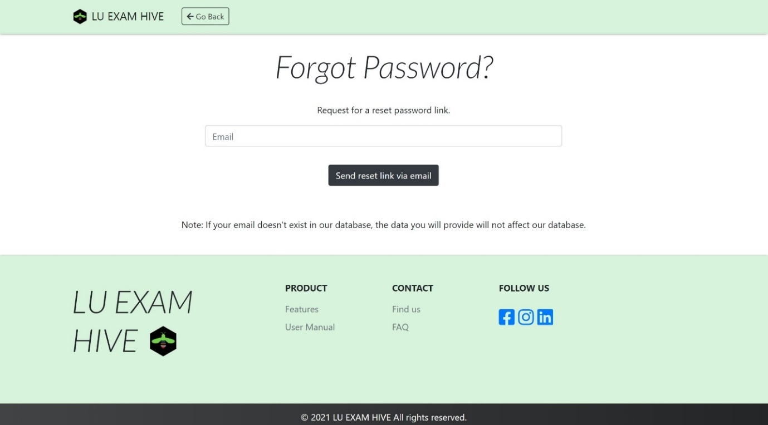

**Figure 19:** Forgot Password of LU Exam Hive

### 8.2.12 Dashboard (Teacher)

Keeping in mind that not all teachers are familiar to complex UI of a dashboard of online exam platforms, thus we designed easy to understand dashboard for easy navigation. Creating Meeting Links, Questions, edit questions, deleting them Posting or keeping a Draft of Question for later post, seeing self-posted questions, viewing own questions, checking submitted solutions from students, marking them and then generating a pdf of the result sheet. Yes, we have it all under one platform.

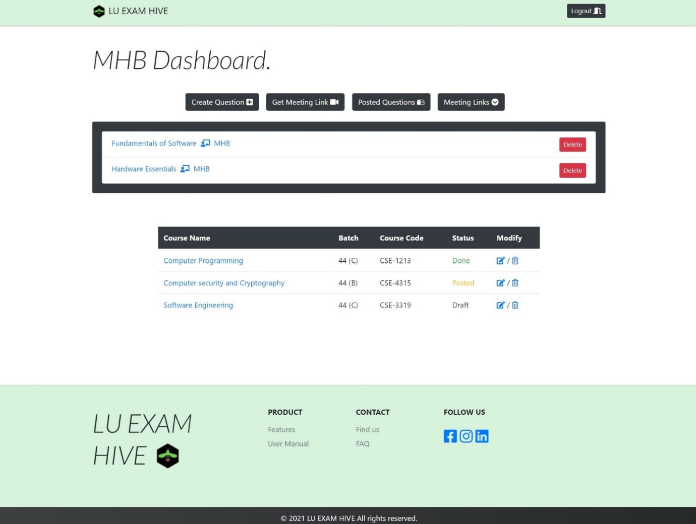

**Figure 20:** Teacher Dashboard of LU Exam Hive

### 8.2.13 Create Question (Teacher)

In this area teachers will fill in the details of a section whose exam or assignment is to be conducted. It is to be kept in mind that Summernote is integrated to the Question making section of the website. (Summernote is a JavaScript library that helps you create WYSIWYG editors online. Summernote is built on jQuery.) Thus, Teachers can attach any pictures easily to the questions and do much more.

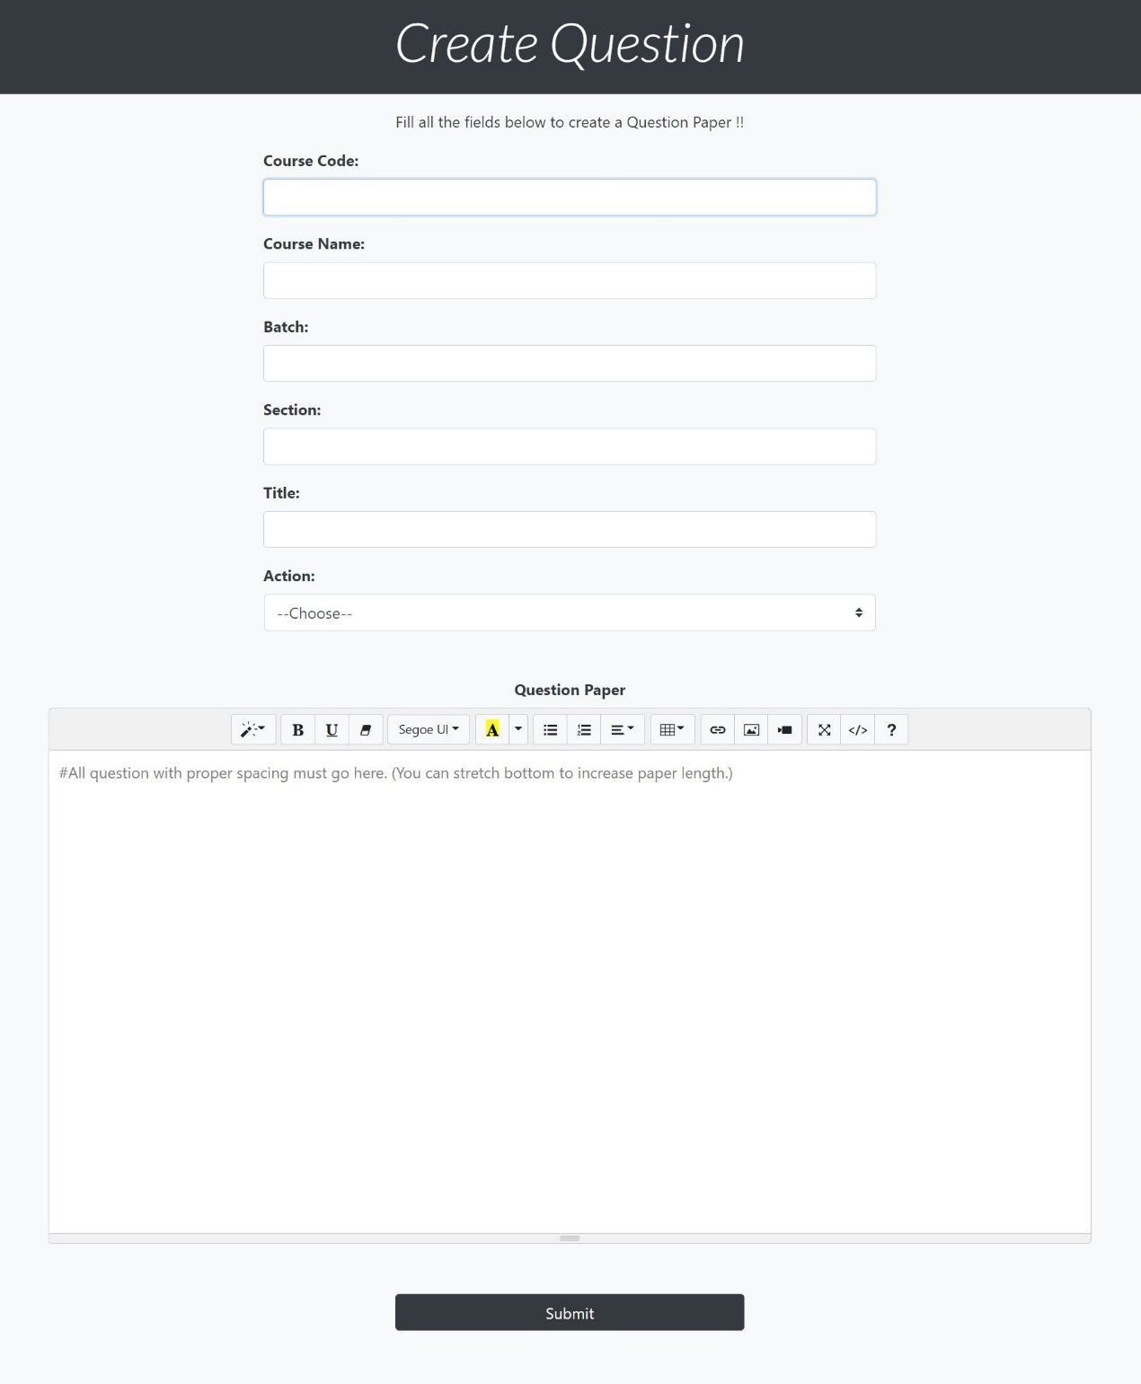

**Figure 21:** Create Question of LU Exam Hive

### 8.2.14 Create Meeting (Teacher)

LU Exam Hive integrates the 2 most popular meeting apps Google meet and Zoom into the website so teachers have all the necessities sorted in under one platform. Teachers on clicking any of 2 meeting buttons will be taken to the following sites to schedule a date for meeting and the link obtained will be copied by the teachers and pasted into our Meeting Link input field. On save teachers will get their meeting links organized in their dashboard.

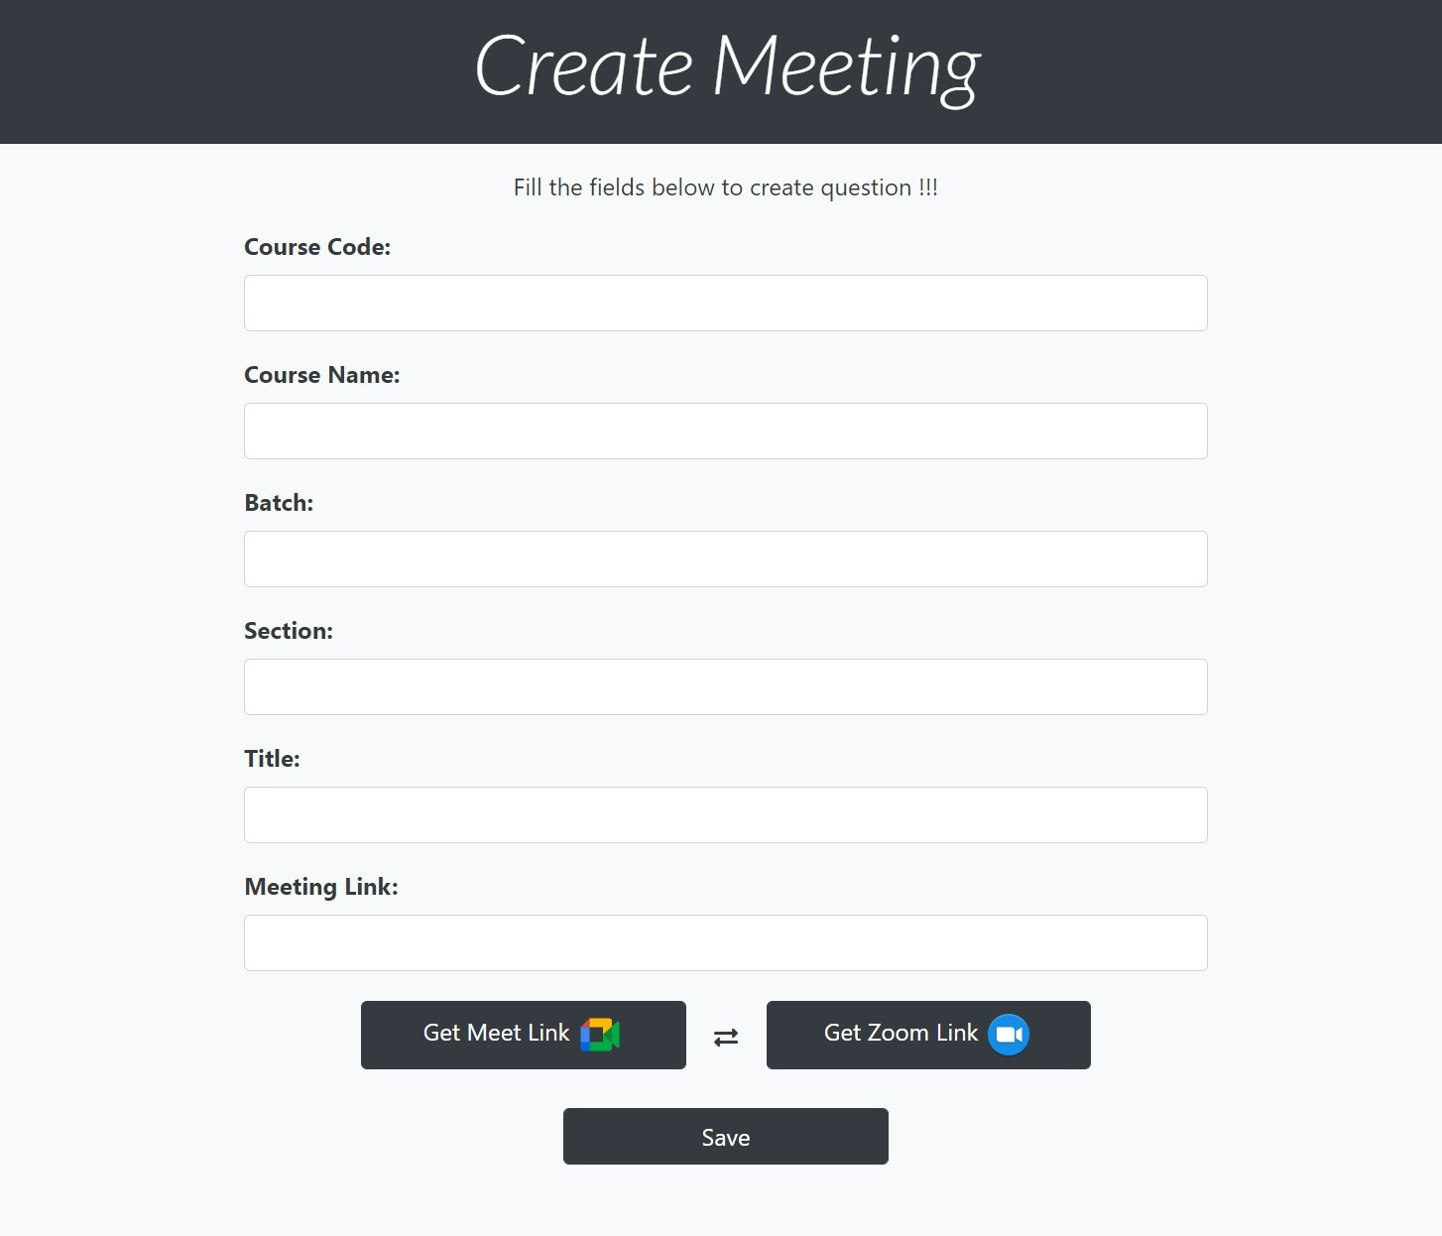

**Figure 22:** Create Meeting of Lu Exam Hive

### 8.2.15 Edit Question (Teacher)

Here teachers will be able to edit their questions after making them. If teachers didn’t choose any Action before or kept it to be Draft or Post and want to change it to something else can be performed here.

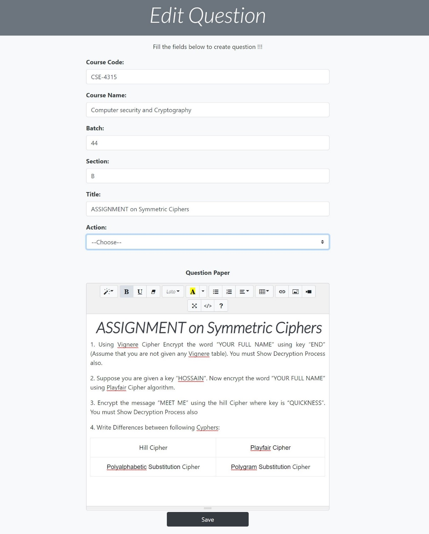

**Figure 23:** Edit Question of LU Exam Hive

### 8.2.16 Question View (Teacher)

Teachers after making a question can view how it will appear on screen for students in this section and can also check the solutions submitted by students by clicking the submissions and result button.

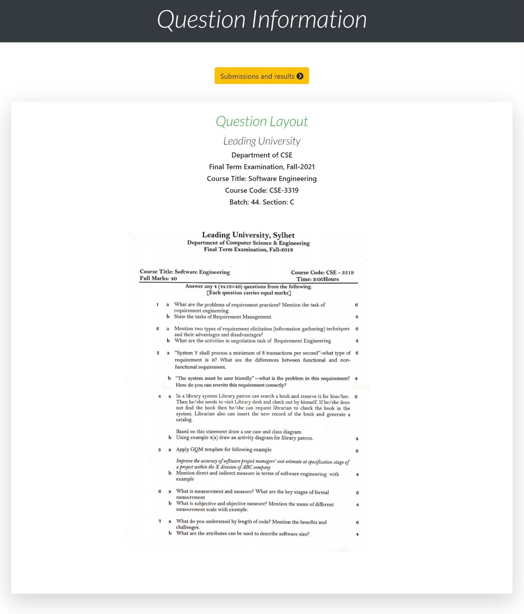

**Figure 24:** Question View of LU Exam Hive

### 8.2.17 Posts (Teacher & Student)

This section displays the current posts of every teachers. It is visible to both teachers and students.

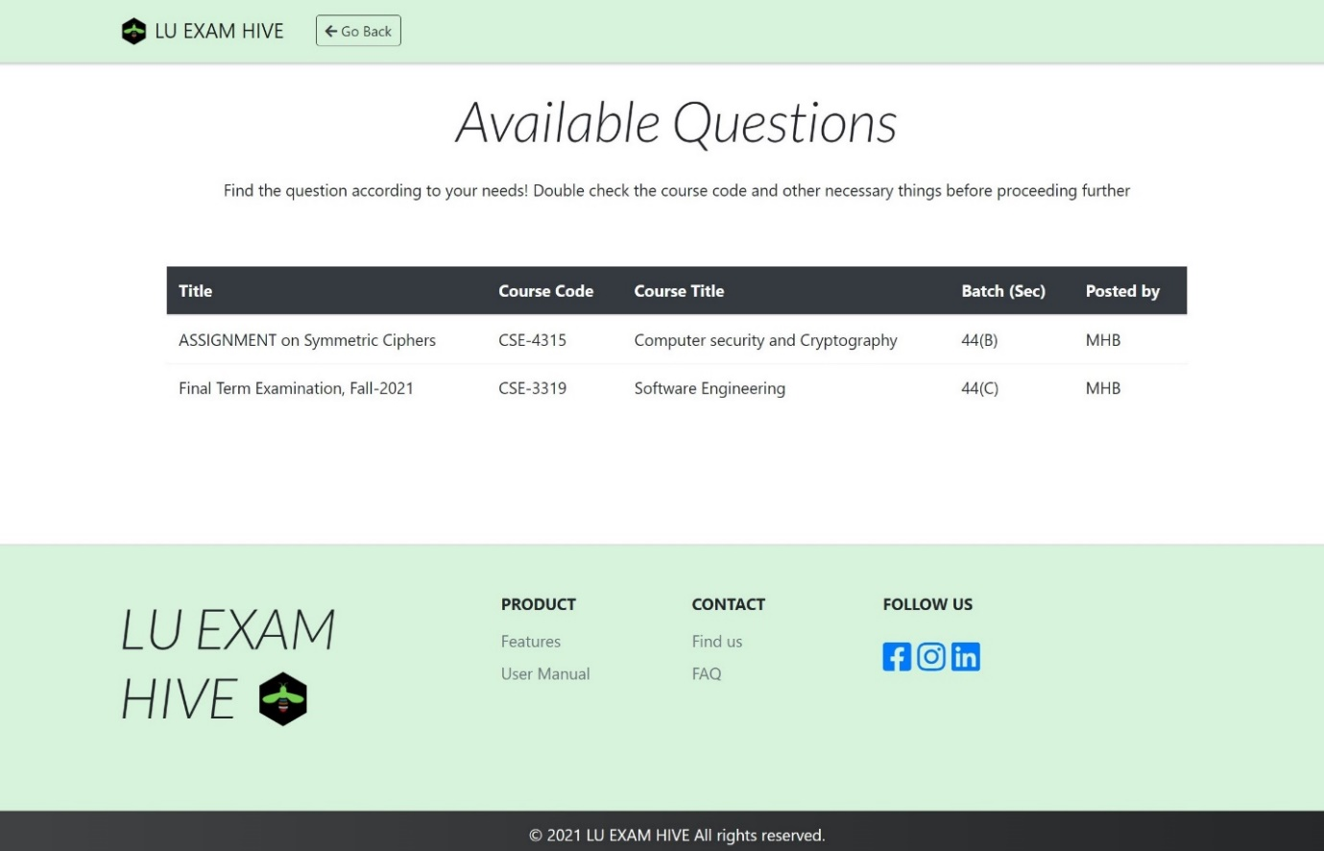

**Figure 25:** Posts of LU Exam Hive

### 8.2.18 Submissions (Teacher)

All submitted solutions from students will appear here.

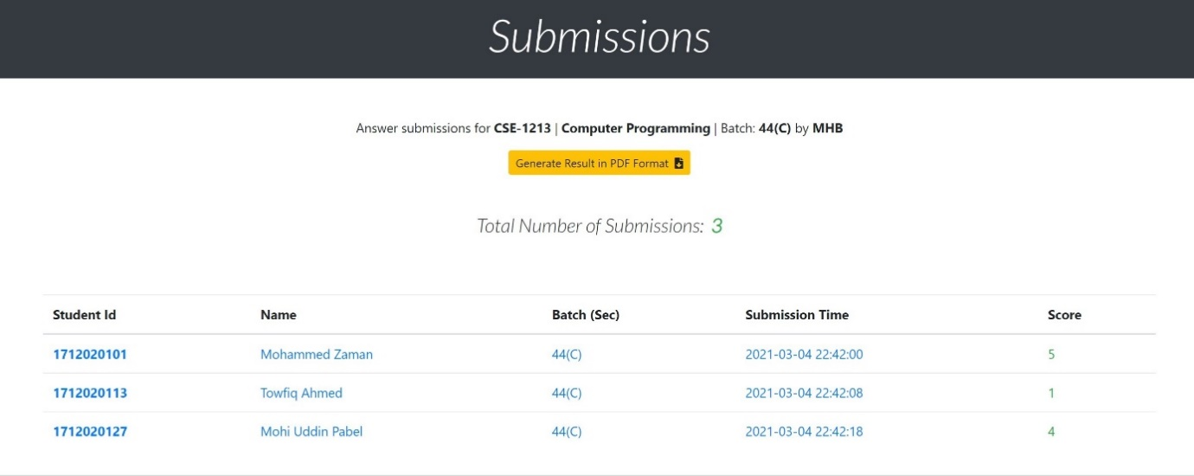

**Figure 26:** Submissions of LU Exam Hive

### 8.2.19 PDF Generate (Teacher)

Teachers will be able to generate pdf of marks given to student submissions.

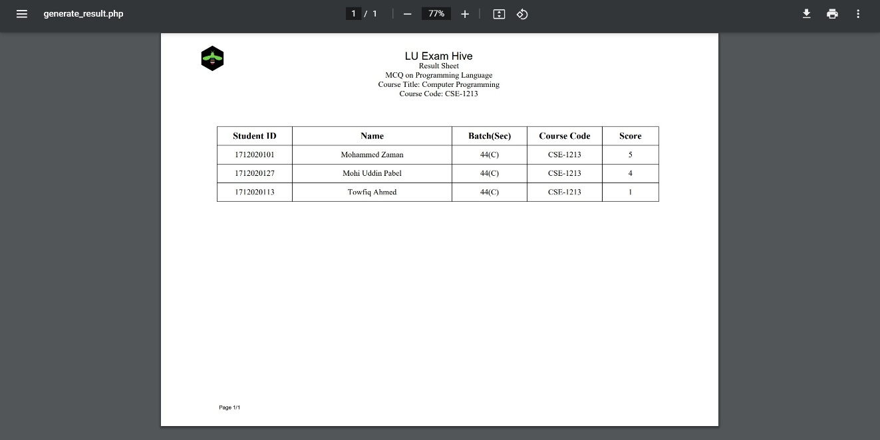

**Figure 27:** PDF Generate of LU Exam Hive

### 8.2.20 Submission Details (Teacher)

Teachers will be able to check solutions of students keeping questions in front of them and provide them a score.

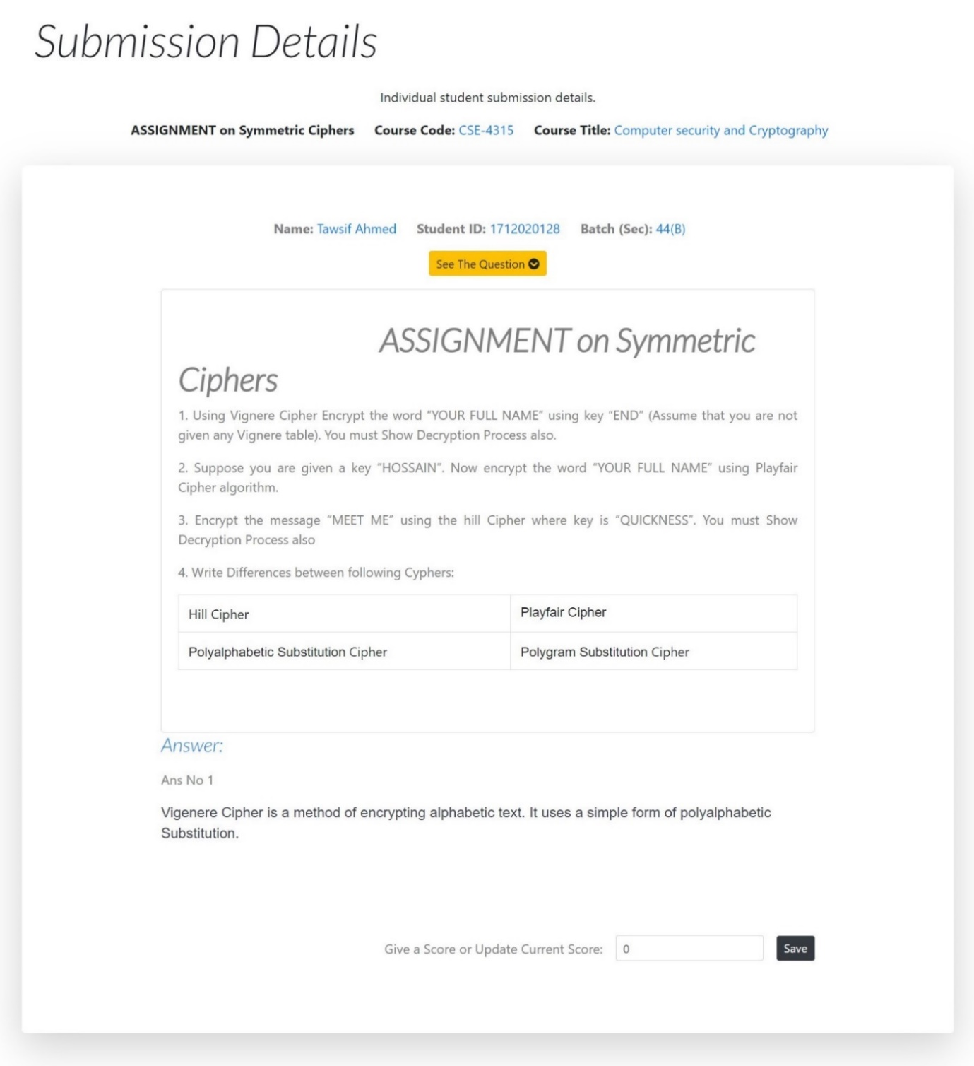

**Figure 28:** Submission Details of LU Exam Hive

### 8.2.21 Dashboard (Student)

We simplified student’s dashboard keeping in mind not all students are used to complexity of online exam platforms. The table here generates only exams and meetings that is taking place within his/her section only and in case if a student wants to give exam with some other section can easily move to All Posted Questions where Exam details of all sections are present.

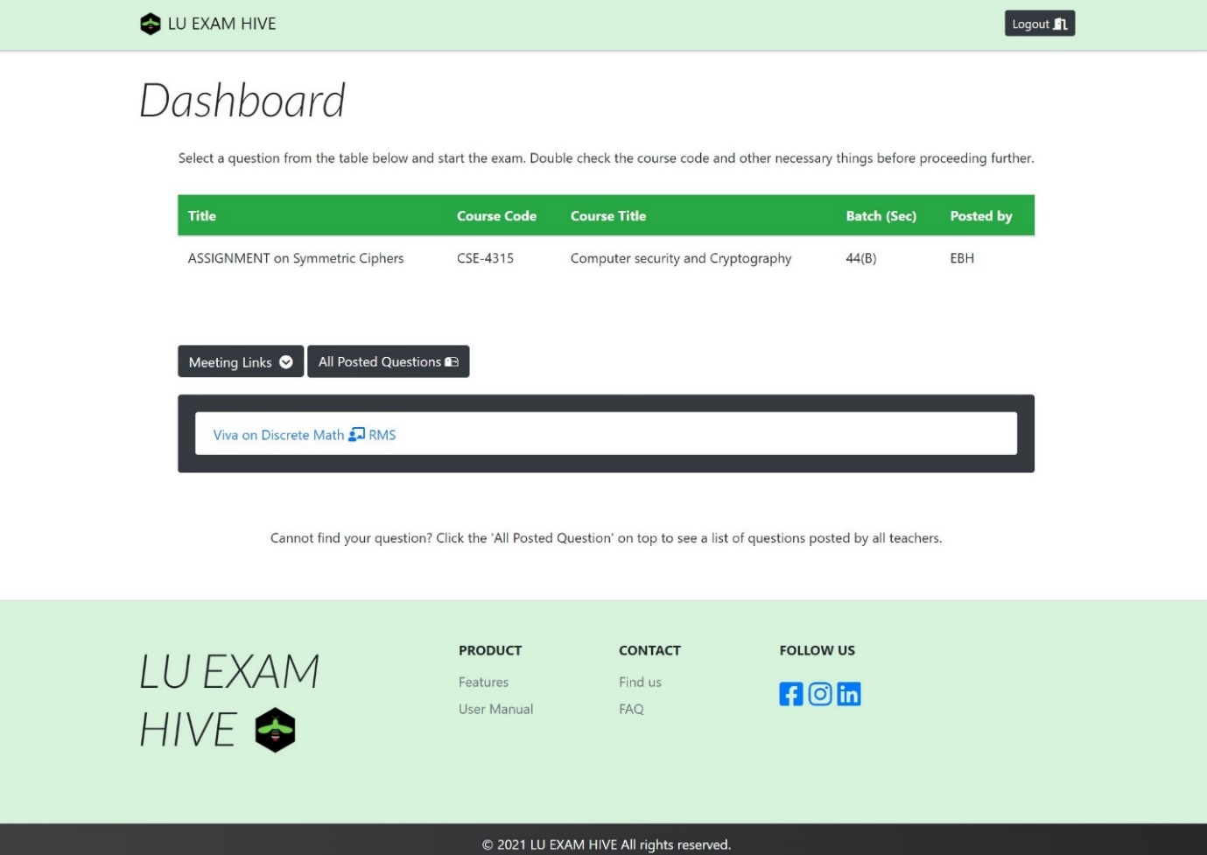

**Figure 29:** Student Dashboard of LU Exam Hive

### 8.2.22 Answer Script (Student)

Students will answer in this section. They will have to attach their details before writing anything on the answer script. There is a digital clock integrated so they can keep tract of their time.

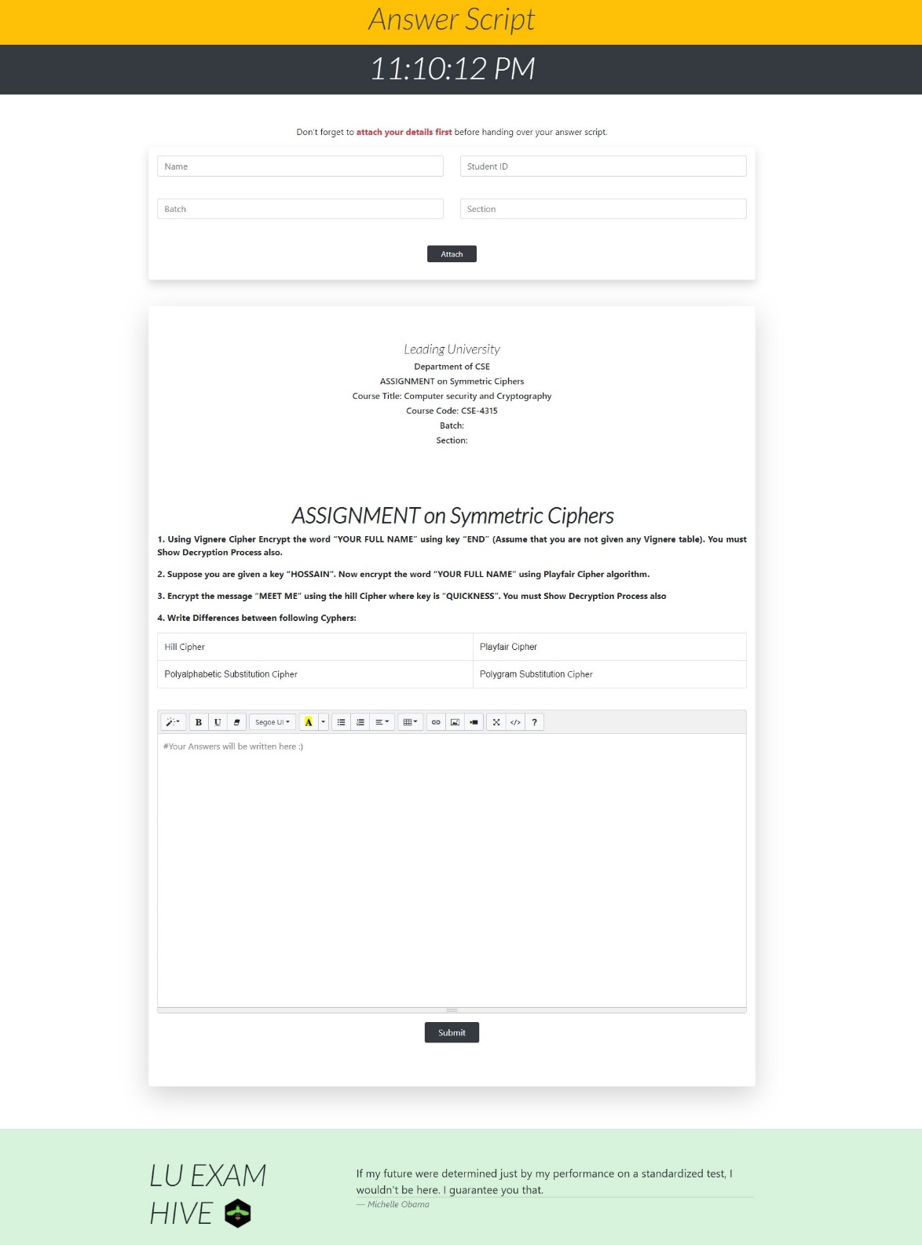

**Figure 30:** Answer Script of LU Exam Hive

### 8.2.23 Dashboard (Admin)

Designed with simplicity in mind. Admin has access to all the details of user in the platform and contacting users.

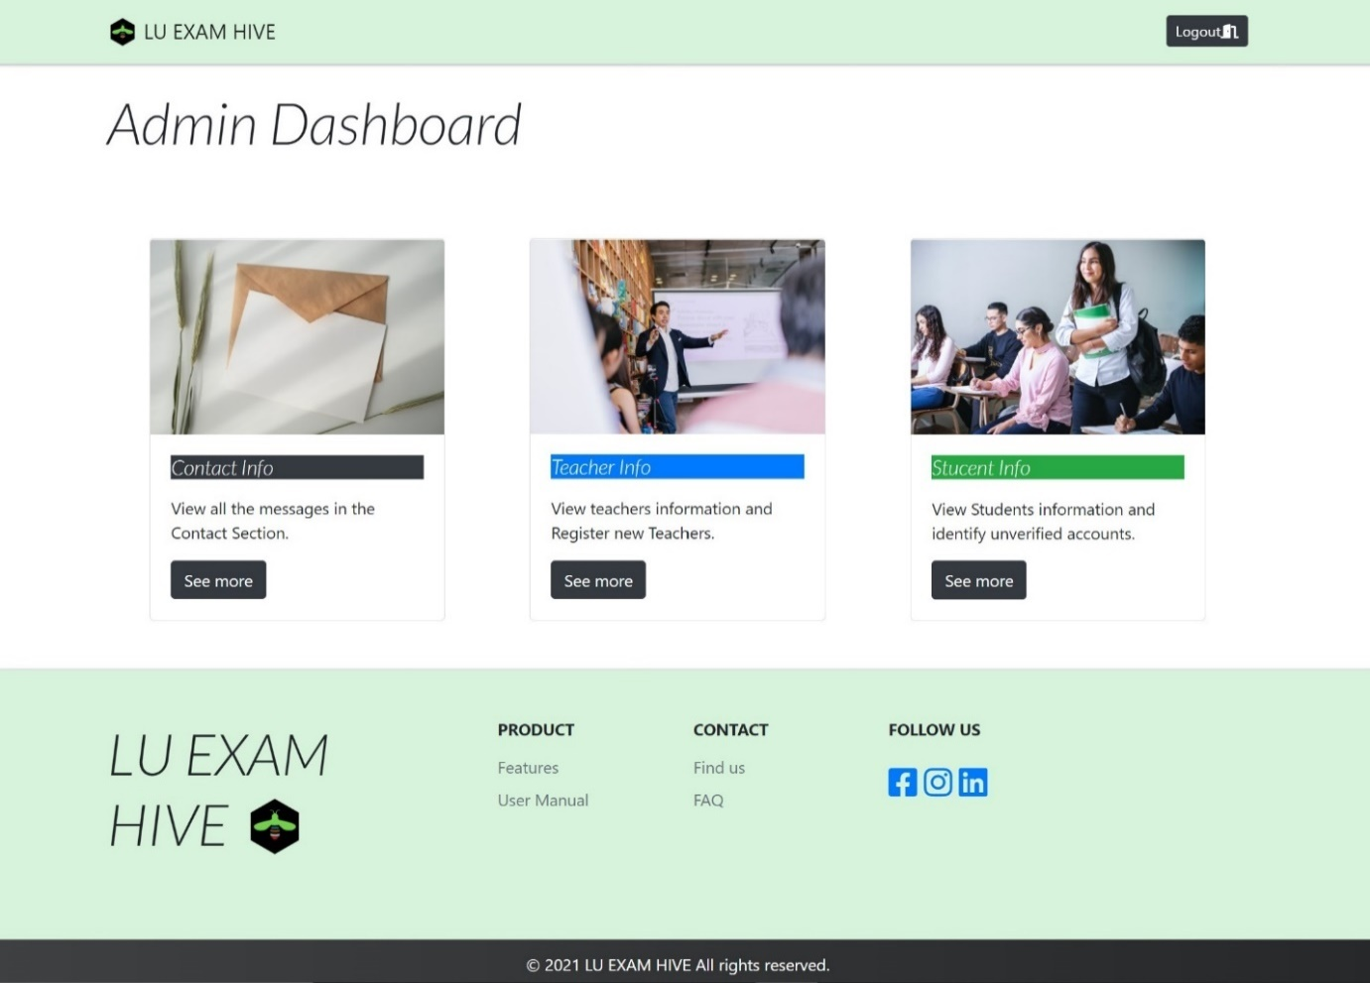

**Figure 31:** Admin Dashboard of LU Exam Hive

### 8.2.24 Contact Info (Admin)

Here admins will have information of all the users contacting the website.

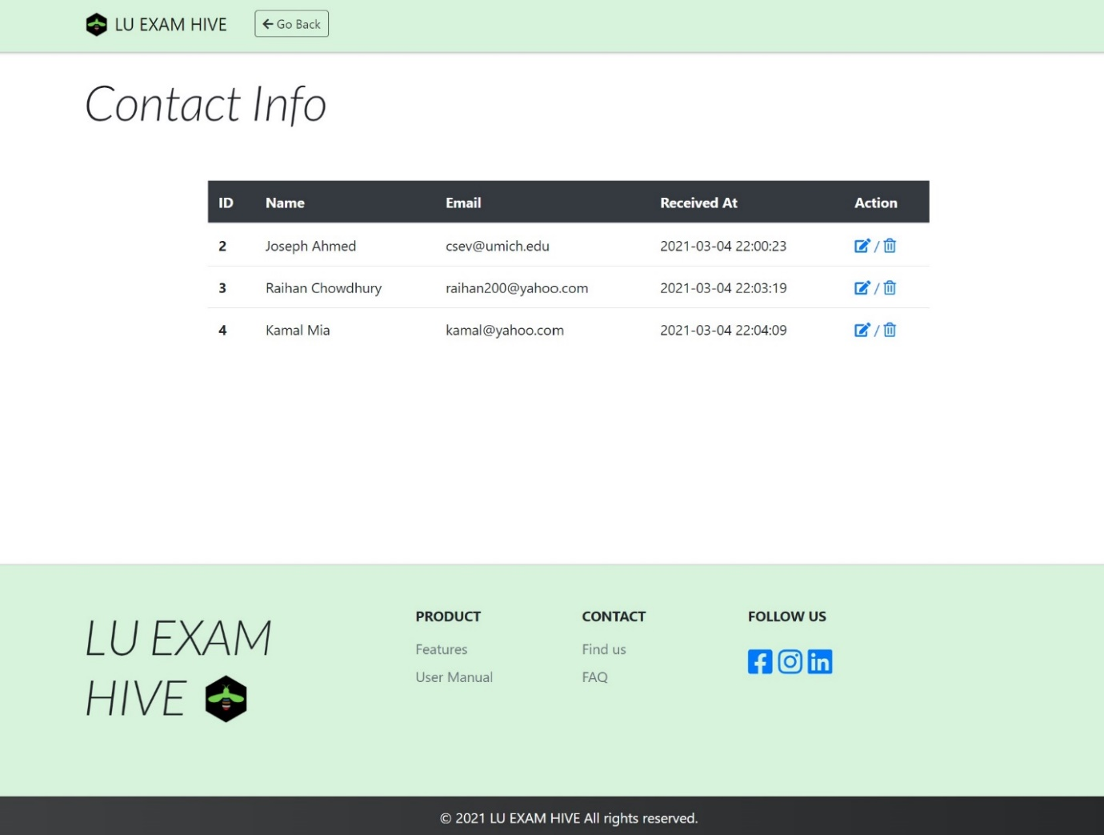

**Figure 32:** Contact Info of LU Exam Hive

### 8.2.25 Contact Info Delete (Admin)

Admin can view the message of the contact and also delete it.

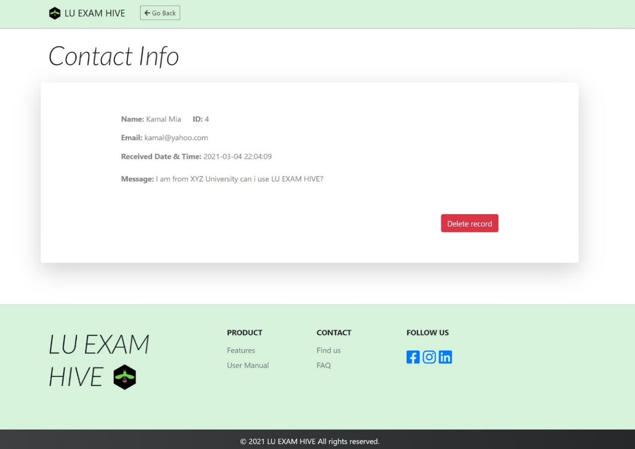

**Figure 33:** Contact Info Delete of LU Exam Hive

### 8.2.26 Teacher Info (Admin)

Admin can view the teachers registered to the platform here and also go onto add new Teachers to the site.

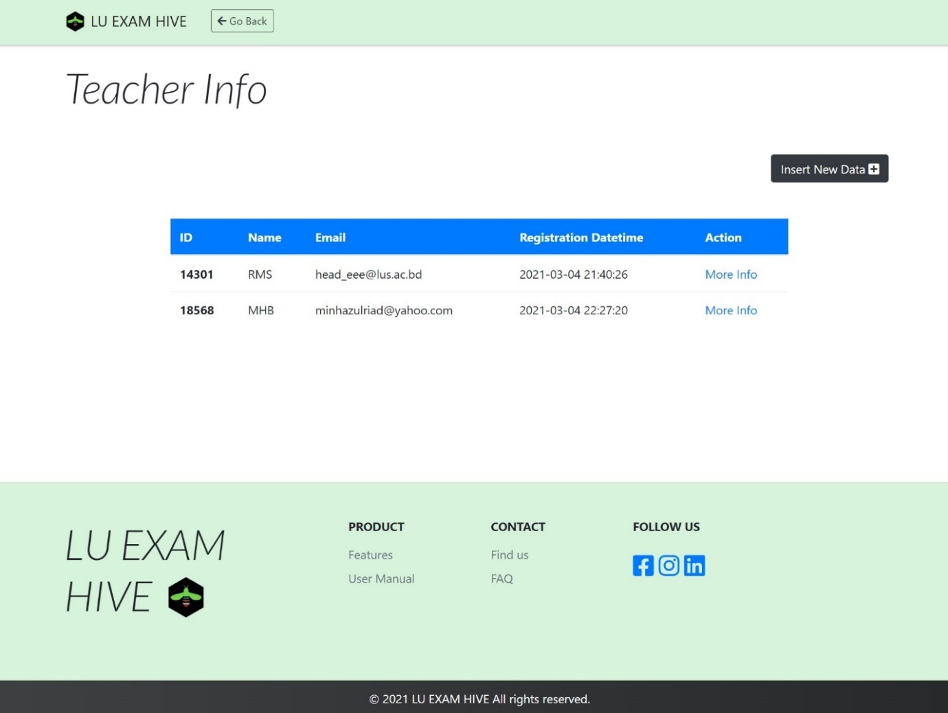

**Figure 34:** Teacher info of LU Exam Hive

### 8.2.27 Insert Teacher Info (Admin)

Admin will be able to add new teacher by filling up the following.

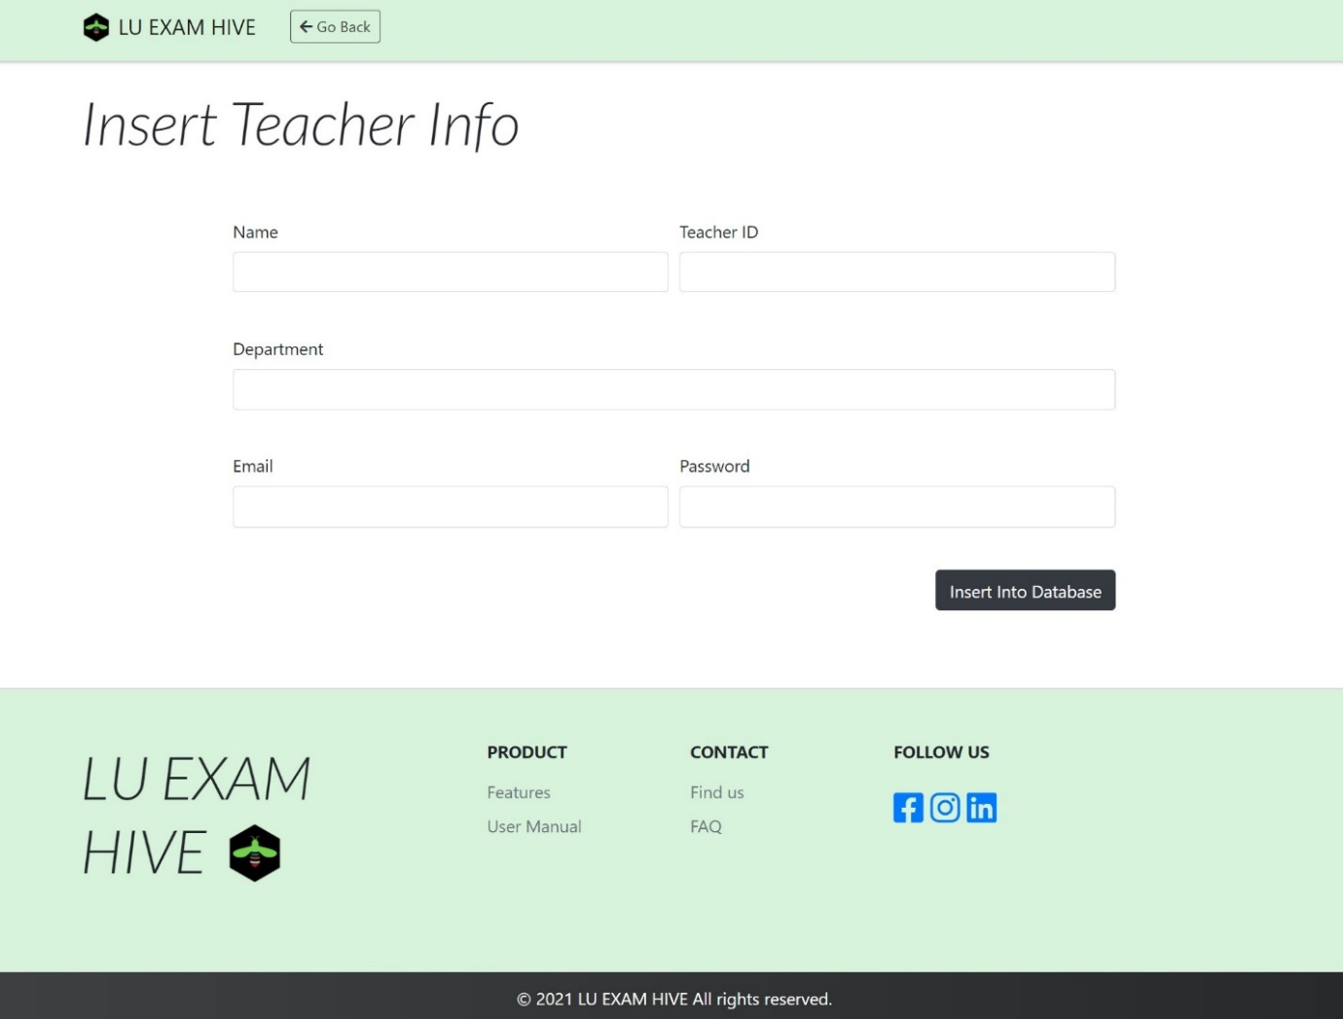

**Figure 35:** Insert Teacher Info of LU Exam Hive

### 8.2.28 Student Info (Admin)

Admin will get a batch wise student details (includes number of student present in each batch) and also search for a specific student id and acquire all information easily.

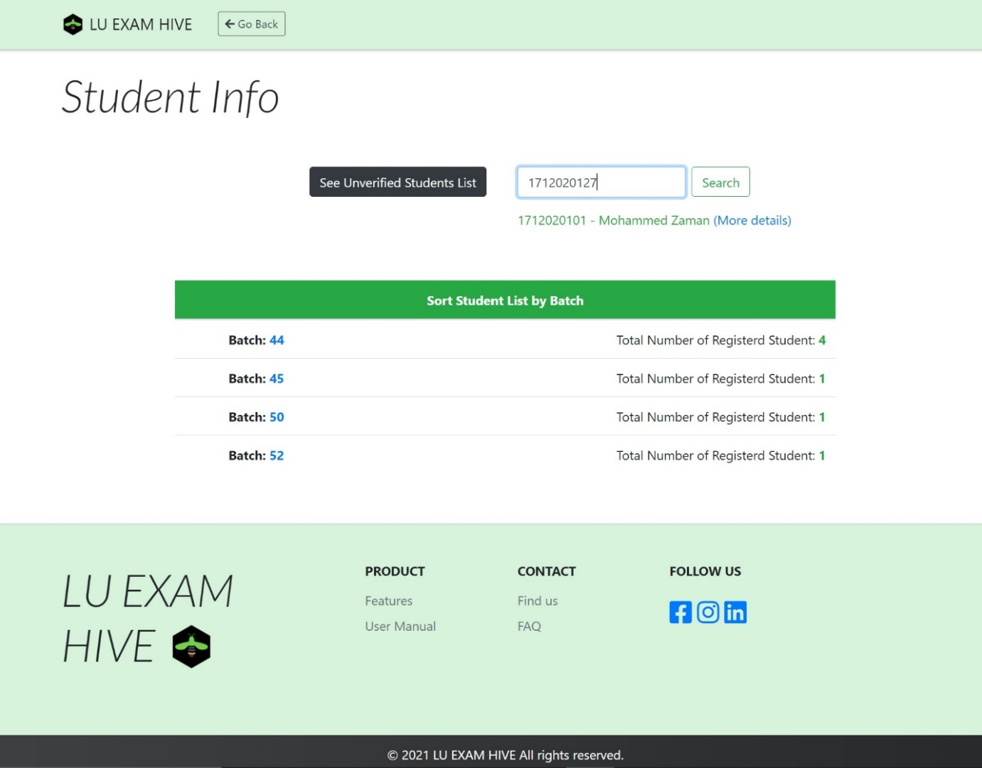

**Figure 36:** Student Info of LU Exam Hive

### 8.2.29 Unverified Email List (Admin)

Admin can easily detect which users are still unverified and can take actions.

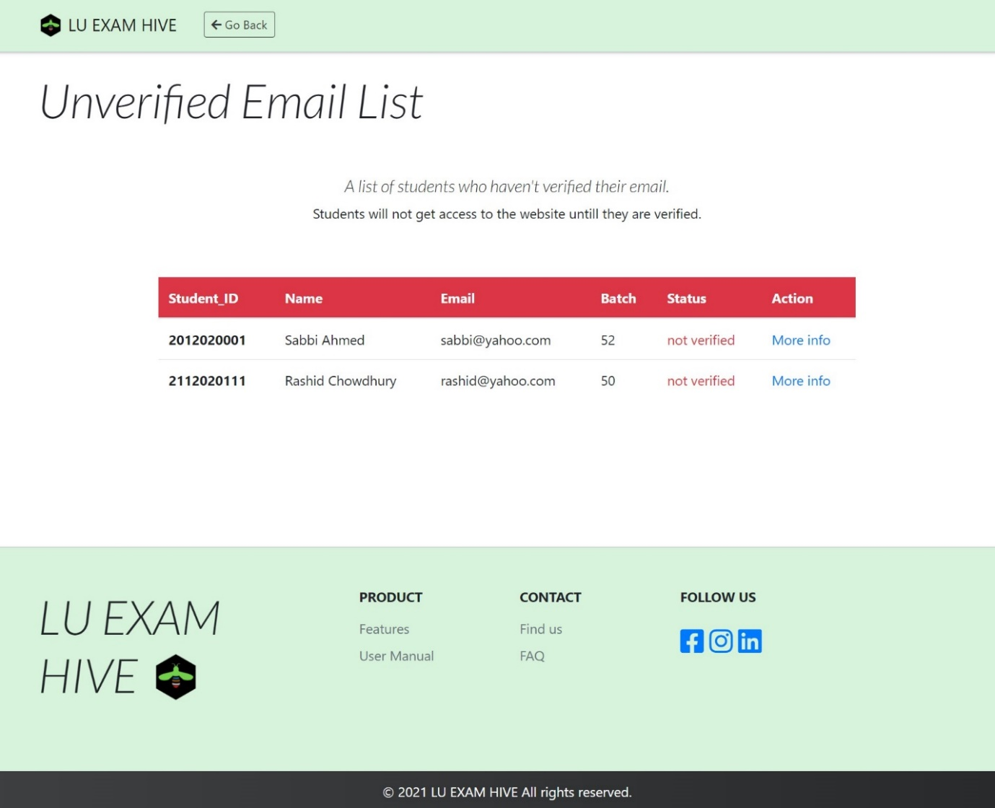

**Figure 37:** Unverified email list of LU Exam Hive

### 8.2.30 Student Details (Admin)

Admin has the power to view details of a student’s LU Exam Hive account and also delete their account.

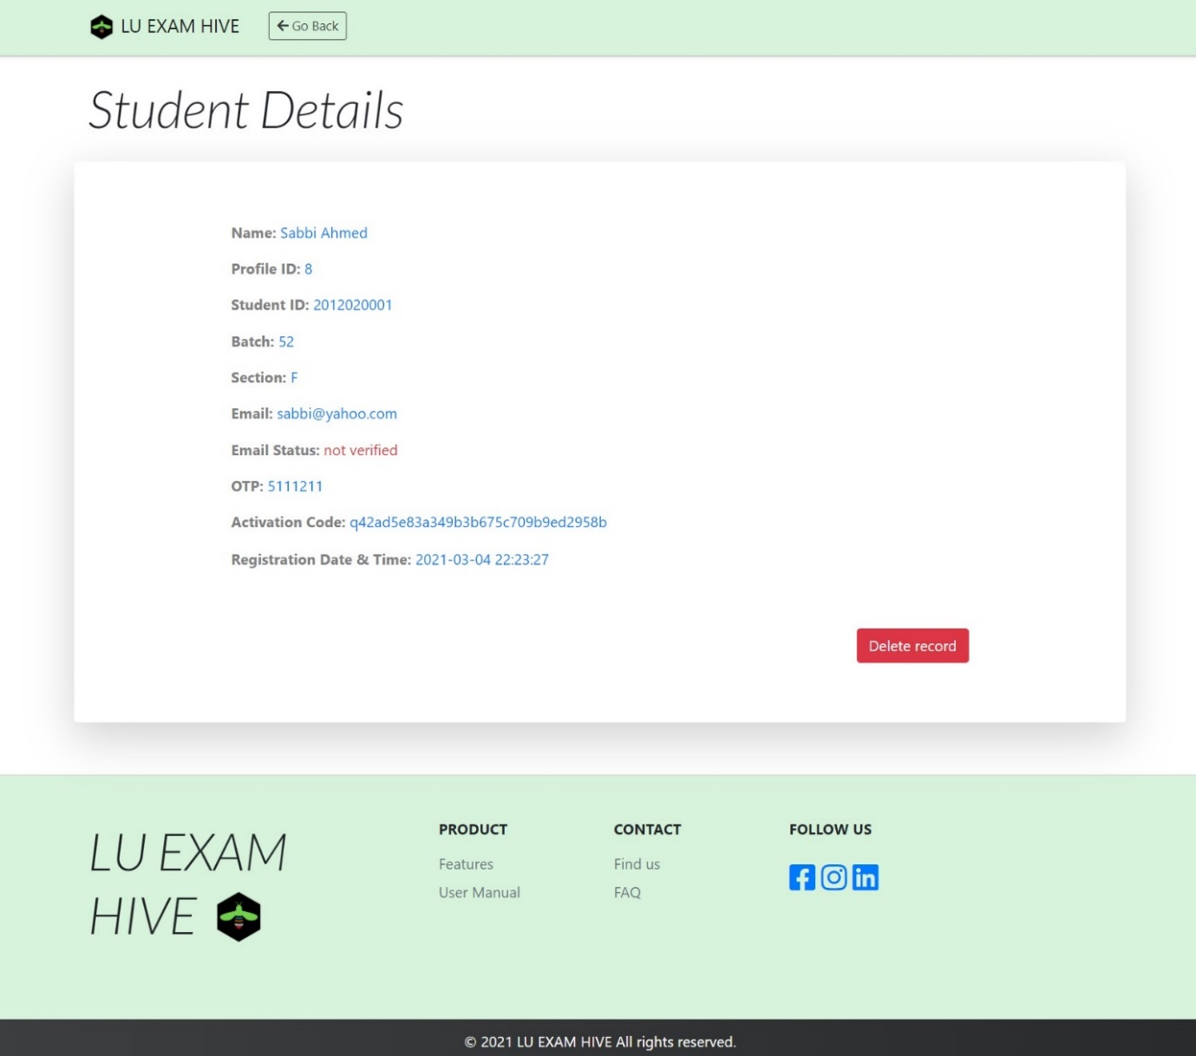

**Figure 38:** Student Details of LU Exam Hive

### 8.2.31 Student Info by Batch (Admin)

Admins are given further ease to look into a particular batch and its sub sections.

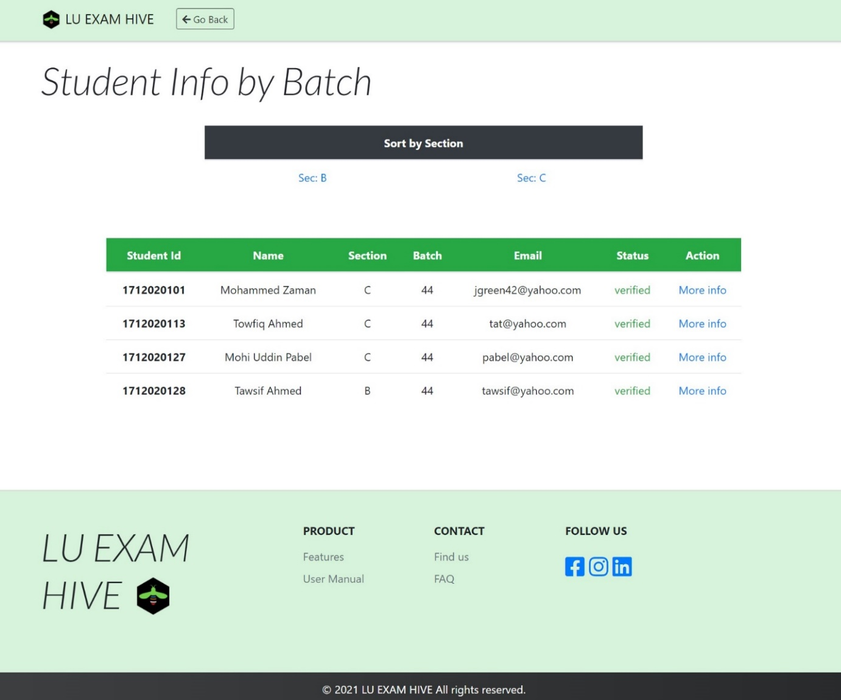

**Figure 39:** Student Info by Batch of LU Exam Hive

### 8.2.32 Student Info by Section (Admin)

Admin can further view individual section and the number of students registered under them and more details on them.

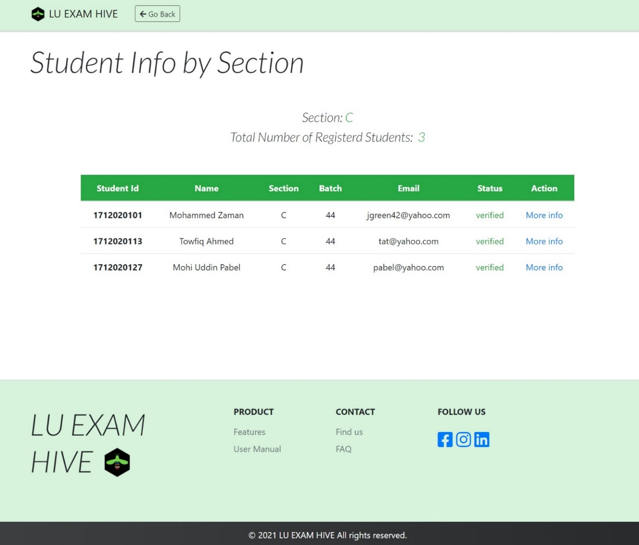

**Figure 40:** Student Info by Section of LU Exam Hive

### 8.2.33 LU Exam Hive (Logo)

The logo below is the Symbol of LU Exam Hive Online Examination System. LU Exam Hive has been created for Leading University Students Only. Leading University community has 4 distinct groups i.e., Teacher, Student, Administration and Staff. Here green resembles student, blue denote teacher, red points to the administration and the black is for the staff in transportation, and brown denotes the soil that holds all of us together in place, we all are connected to the same soil even though we have distinct roles in society. The colors are picked according to the ID card color used within our university premises. A student on his/her own can hardly succeed in life but together with proper guidance from professional teachers and well-organized institution can reach the peak sooner then he/she expected. Such is the moto of the symbol below.



**Figure 41:** LU Exam Hive Logo

# Chapter – 9

# Implementation

There are several functionalities on our website. To demonstrate, some of the code implementations are given below:

## 9.1 Login-Logout Functionalities

Login and Logout are restricted to the particular user

* **Admin Login-Logout**

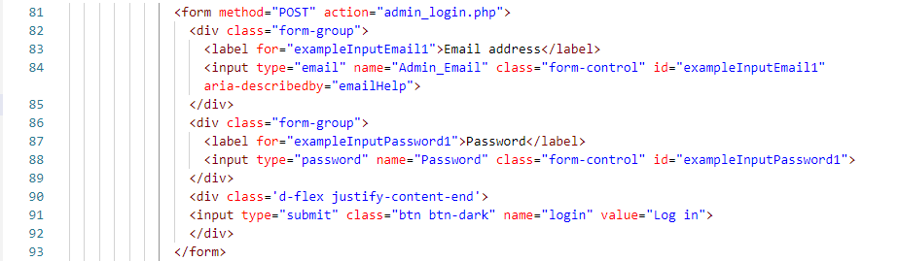

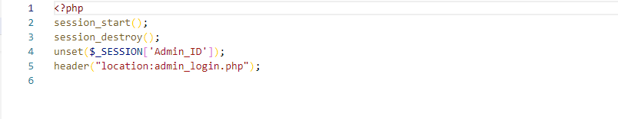

* **Teacher Login-Logout**

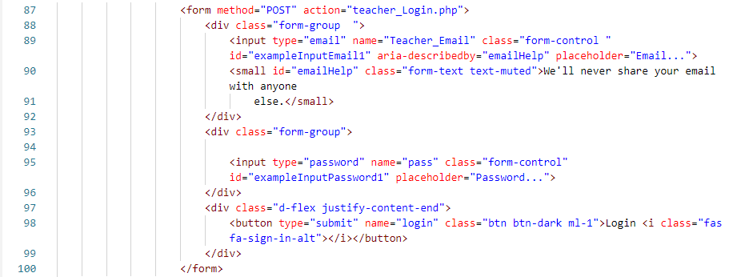

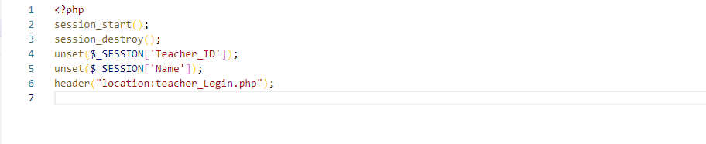

* **Student Login-Logout**

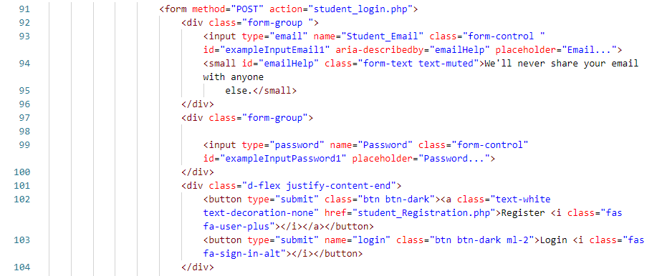

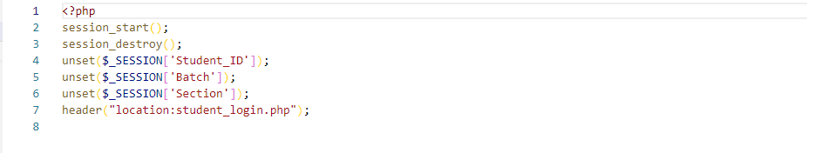

## 9.2 Student Registration Functionalities

* **Student Registration**

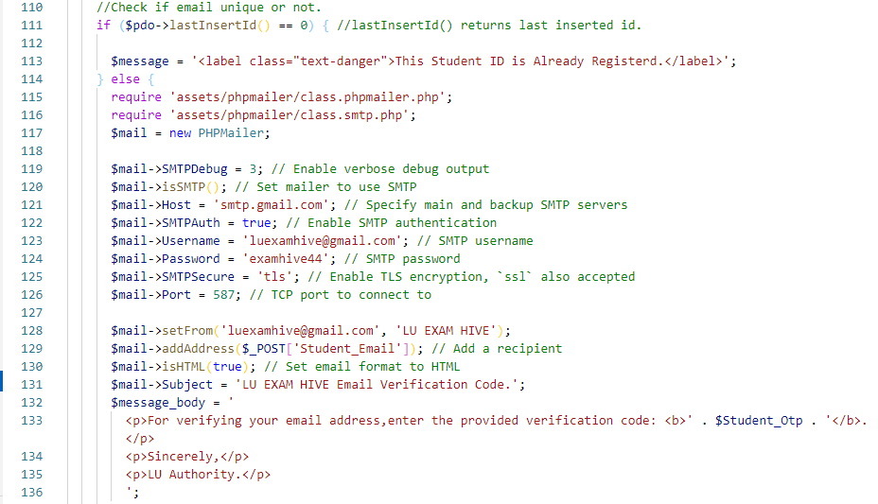

* **OTP**

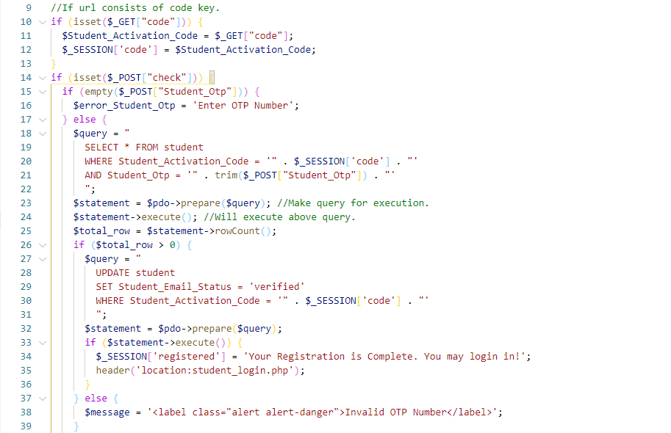

* **Reset password**

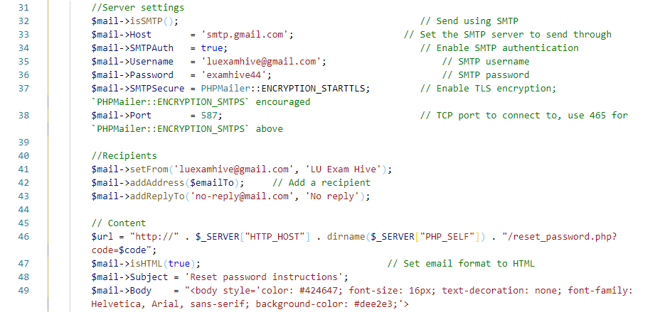

* **Request Reset Password**

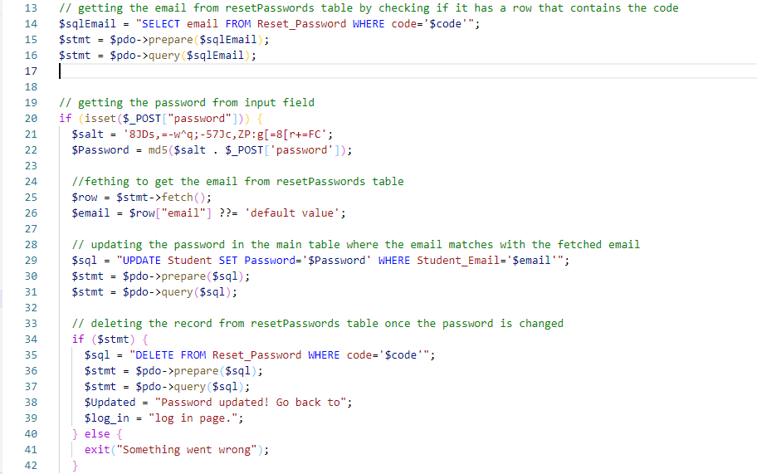

## 9.3 Teacher Dashboard

* **Create Question**

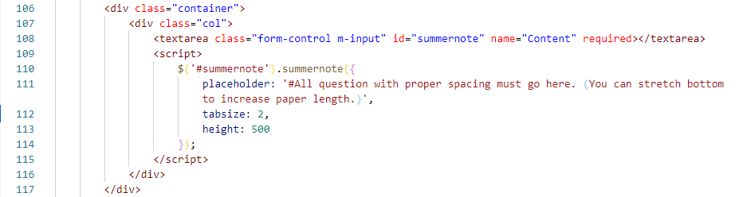

* **Create Meeting**

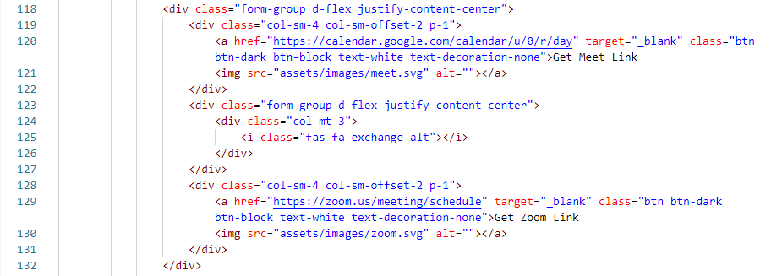

* **Posted Question**

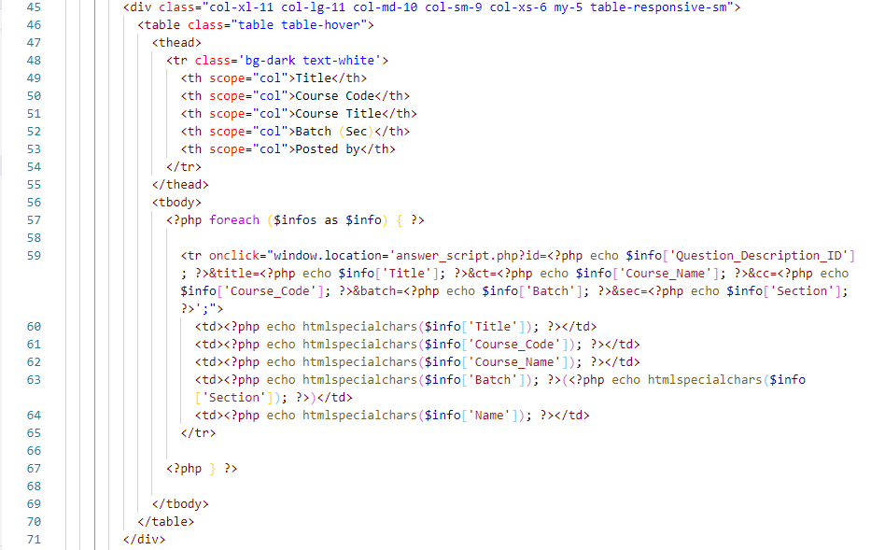

* **Question View**

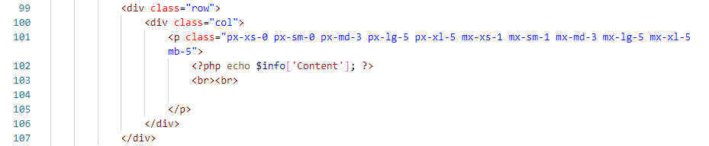

* **Question Submissions**

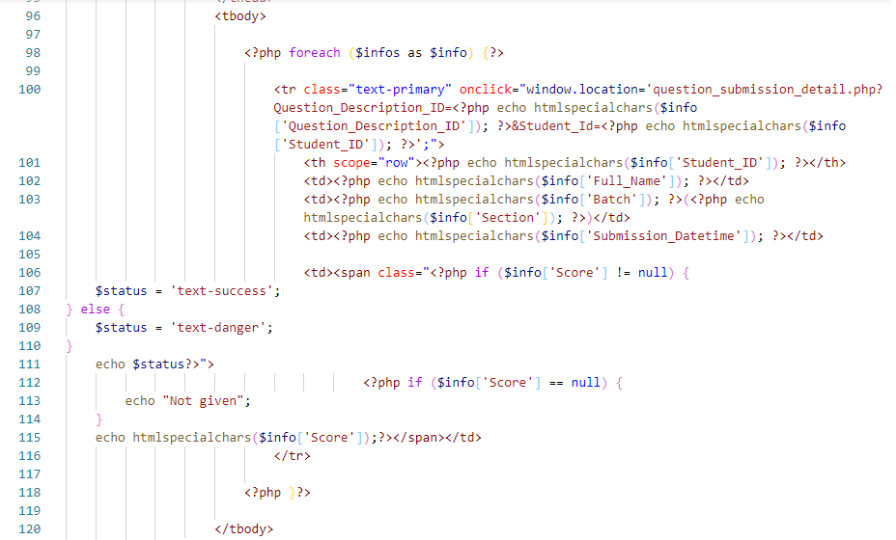

* **Generate Result**

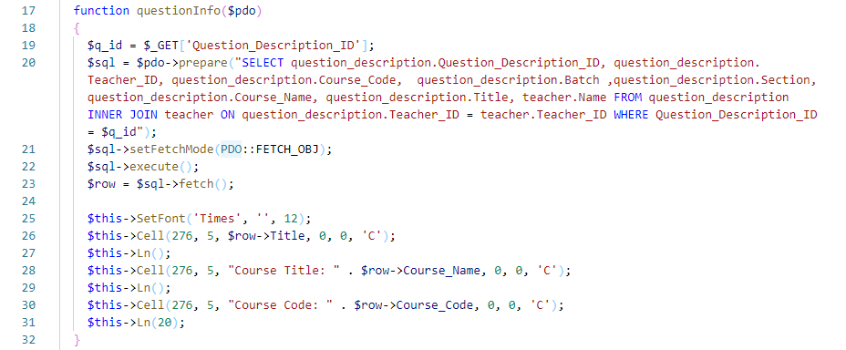

* **Submission Details**

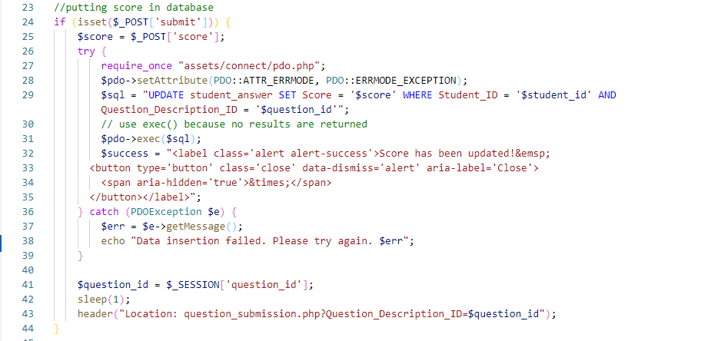

* **Edit question**

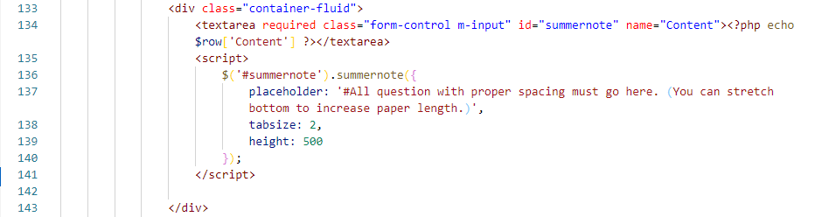

* **Delete Question**

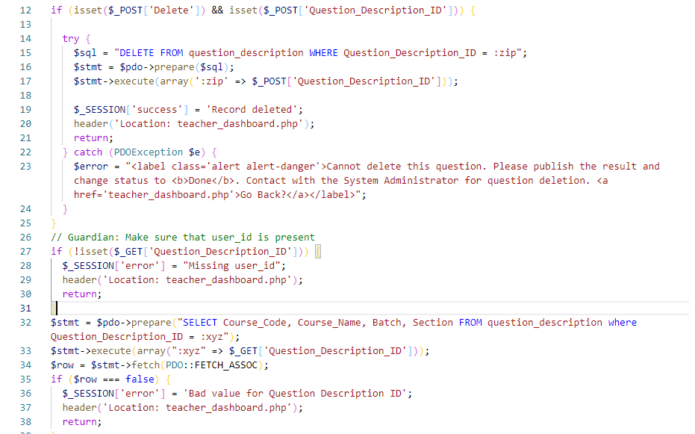

## 9.4 Student Dashboard

* **Dashboard**

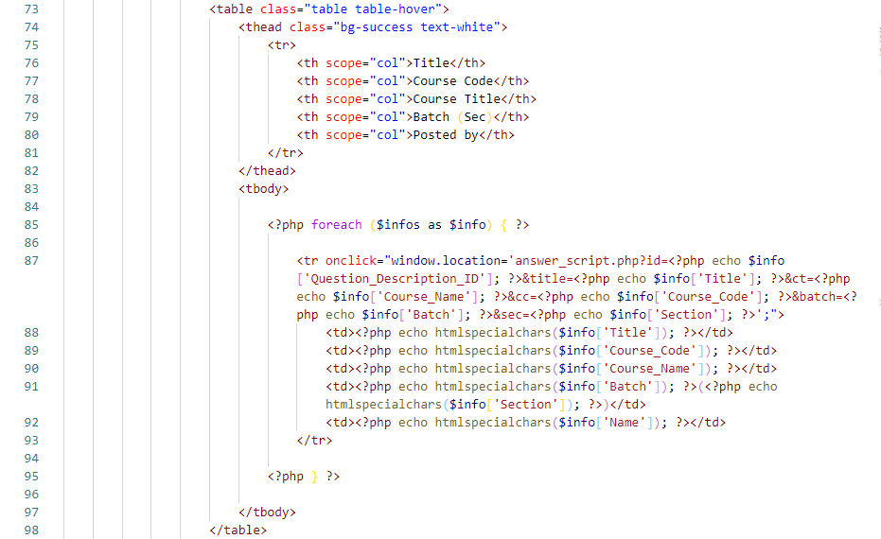

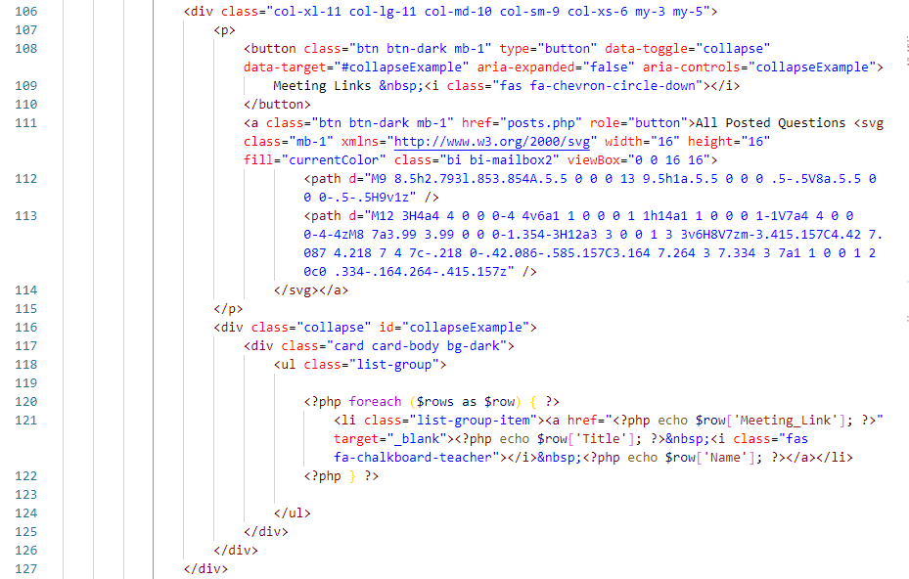

* **Answer Script**

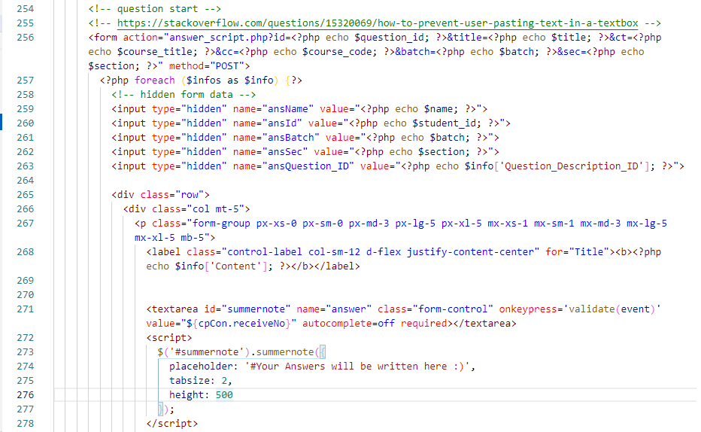

## 9.5 Admin Dashboard

* **Contact Info**

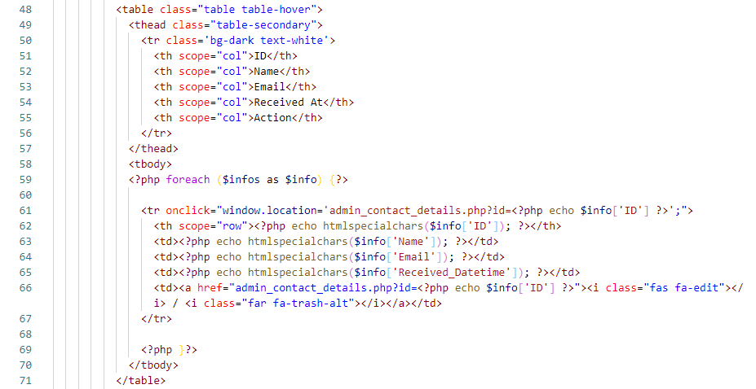

* **Contact Details**

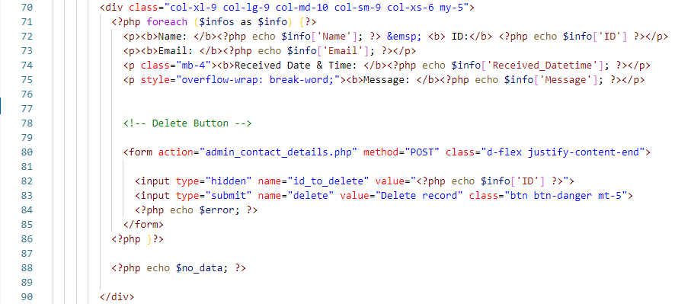

* **Contact Delete**

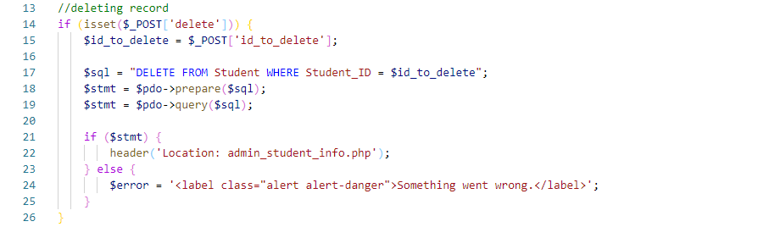

* **Teacher Info**

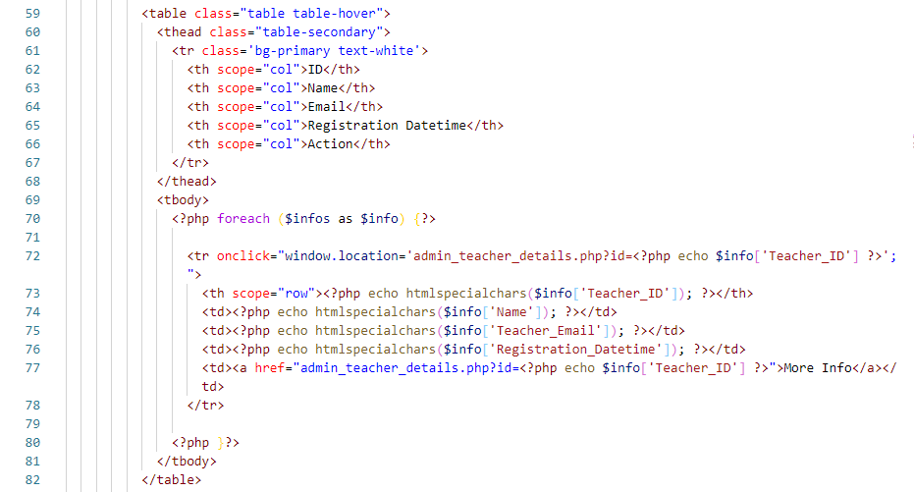

* **Teacher Details**

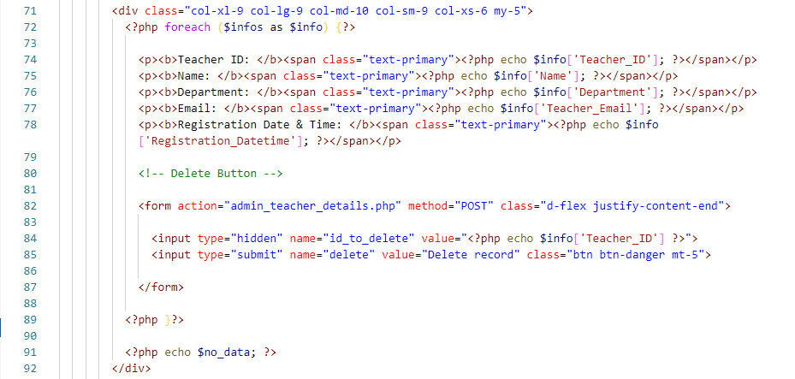

* **Insert Teacher Info**

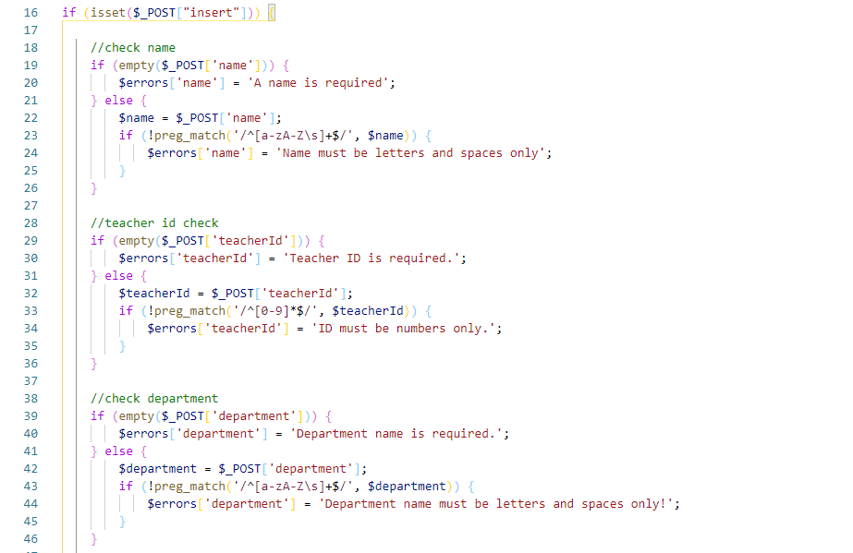

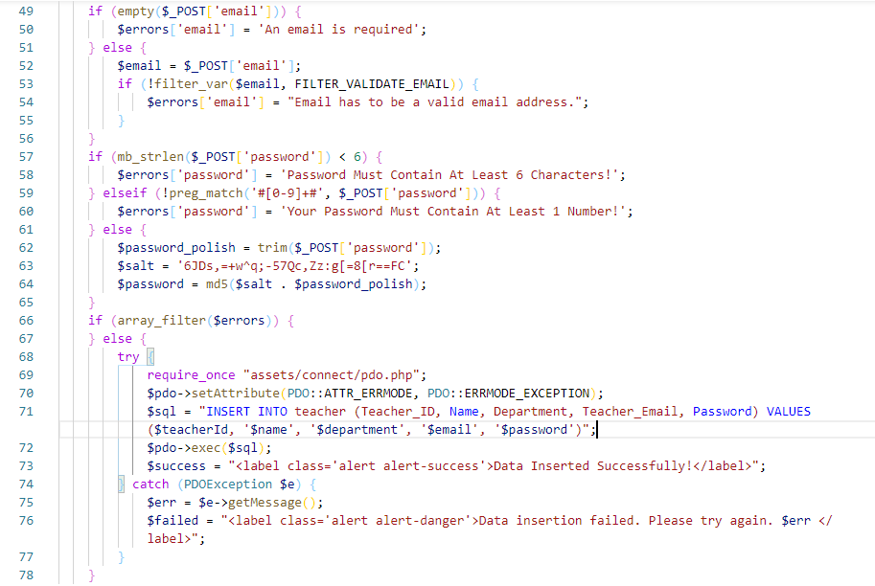

* **Student Info**

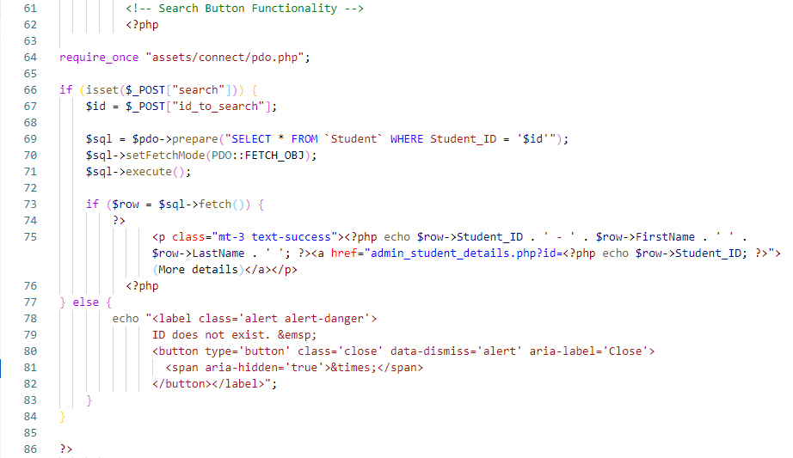

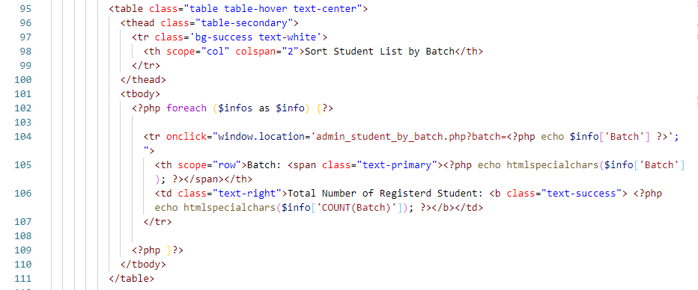

* **Student Details**

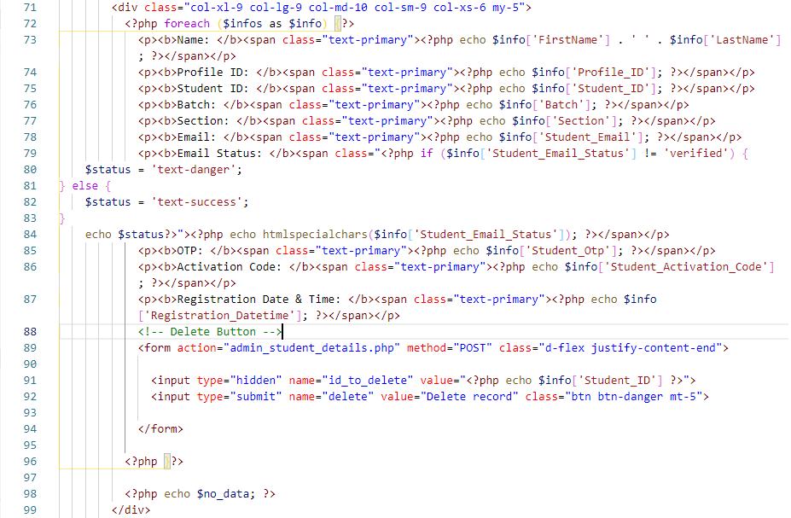

* **Student Info by Batch**

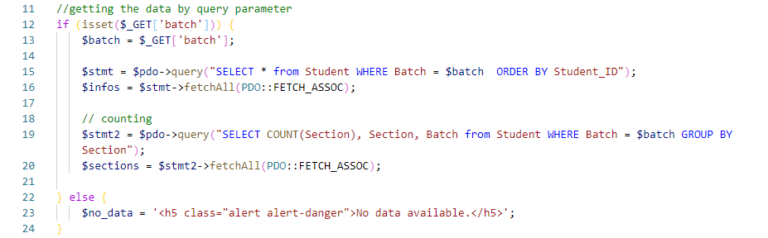

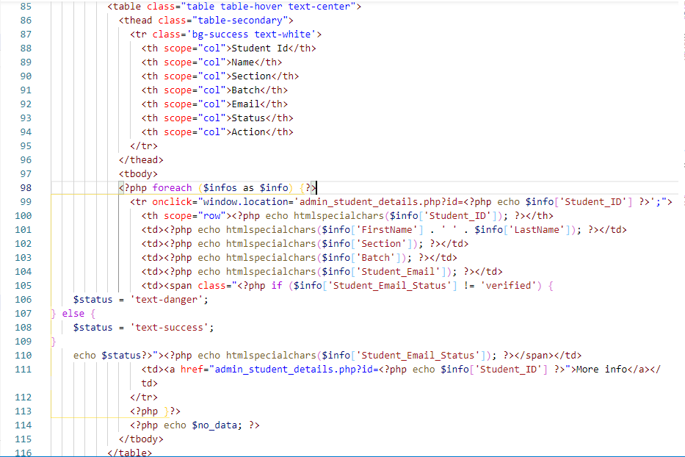

* **Student Info by Section**

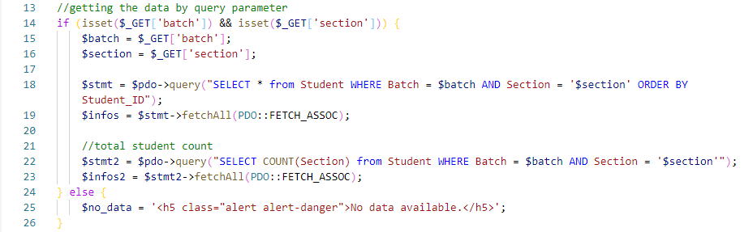

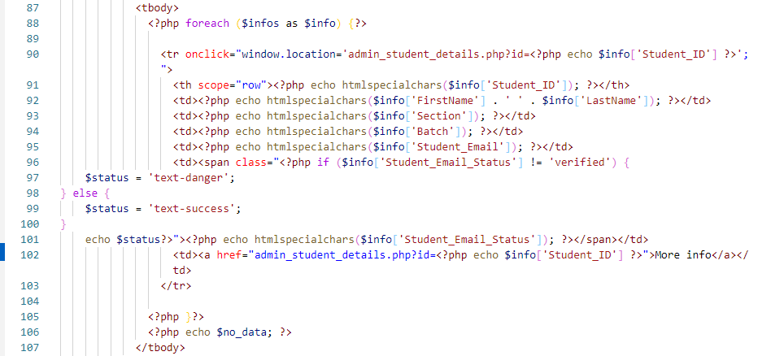

# Chapter – 10

# Testing

This section describes the testing of the project in terms of working environment platform, the main functional requirements and the non-functional requirements achievement according to the predefined objectives.

## 10.1 Platform Testing

The website is tested on different browsers like Google Chrome, Firefox, Microsoft Edge, Opera and other browsers. And it runs perfectly well in all sort of browser. It is also been tested for different views like different model mobile or tablet for determining if it works responsively.

While the testing the website was working totally fine. The question creation and posting question worked perfectly alongside this the generation of meeting link and posting it for the students also was working. The students could see the posted question and also got the meeting link posted by the teacher during the testing.

## 10.2 Requirement Testing

All functional and non-functional requirements are tested. Regarding functional testing the website is working for creating and posting question for the examination and also meeting generation via Google Meet or Zoom are tested. The GUI for this website is simple and attractive also easy to use for the end user.

This website is designed in a way to be flexible for Leading University. That means anyone from Leading University students or teacher can use it from anywhere.

# Chapter – 11

# Conclusion

## 11.1 Conclusion

The project deals with the main functions of the web-based Online Examination System as stated in the introduction. The ultimate goal of this project was to design a website that includes the services of an exam system that can be conducted online whenever needed. Another consideration was there was no such system on our own where a teacher can examine the circumstances like the COVID-19 pandemic. Therefore, we tried this new concept of making an Online Examination System.

The main objectives of the project were achieved and the user of the website can easily handle it. A teacher can create a question to take the exam and also if the teacher wants to conduct a viva or presentation via Google Meet or Zoom can easily schedule the meeting using this website. On the other hand, students can attend the exam remotely from anywhere and also can attend the meeting created by the respective teacher.

The website can run through a web browser like Chrome, Firefox, Microsoft Edge, Opera, and any other web browser.

Finally, it was a good exposure to our work on this project. We learned so many lessons by working together as a team and make a fully functional website within a certain period.

## 11.2 Further Work

However, there are some further works that need to be done.

* The assignment posting and collecting the assignment from the students on time function needs to be added.
* Exam routine publication function for the students’ needs to be implemented.
* We have to consider the auto-checking answer function for the short question-answer so that teacher can easily determine the score of a student.
* Another consideration for the result publication through this website can be added so that a student can easily find his/her result after logging in to his dashboard.
* All the registered student list for the particular semester can be shown in the teacher dashboard, by this, a teacher will be able to determine how many students he/she is dealing with for that semester.
* We want to add quiz type question functionalities that can be made by the teacher if needed
* We added the clock in the answer script but couldn’t execute the stopwatch function, so we want to include the stopwatch function in the answer script.

# References

Adrian, 2020, *Google Forms VS FlexiQuiz,* viewed 10 December 2020, <https://www.saashub.com/compare-google-forms-vs-flexiquiz>

Arefin2k, 2013, *How to Prevent User Pasting Text in a Textbox,* viewed 7 January 2021, <https://stackoverflow.com/questions/15320069/how-to-prevent-user-pasting-text-in-a-textbox>

Biek, M 2008, *Are PDO Prepared Statements Sufficient to Prevent SQL Injection,* viewed 3 February 2021, <https://stackoverflow.com/questions/134099/are-pdo-prepared-statements-sufficient-to-prevent-sql-injection?>

Bruner, E 2020*, Referencing & Citation Styles*, viewed 1 March 2021, <https://www.bachelorprint.eu/academic-writing/referencing-citation-styles/#1591265709453-a720514f-d5be>

Castellano, A 2018, *PHPMailer complete tutorial with examples: How to Send Emails with PHP*, viewed 31 January 2021, <https://alexwebdevelop.com/phpmailer-tutorial/>

FPDF, n.d., *FPDF Library*, viewed 24 February 2021, <http://www.fpdf.org/>

GoodFirms, 2021, *Best Exam Software*, viewed 2 January 2021, <https://www.goodfirms.co/exam-software#buyers-guide>

Guru99, n.d., *What is PHP? Write Your First PHP Program,* viewed 2 November 2020, <https://www.guru99.com/what-is-php-first-php-program.html>

Hernandez, J 2019, *What is Apache? In-Depth Overview of Apache Web Server*, viewed 18 December 2020, <https://www.sumologic.com/blog/apache-web-server-introduction/>

Janoti, W 2016, *FPDF Output Dynamic File Name*, viewed 23 February 2021, <https://stackoverflow.com/questions/35879967/fpdf-output-dynamic-file-name/35880041>

Mack, J 2014, *Five Advantages & Disadvantages Of MySQL*, viewed 13 January 2021, <https://www.datarealm.com/blog/five-advantages-disadvantages-of-mysql/>

Matt, n.d., SVG Backgrounds, viewed 20 February 2021, <https://www.svgbackgrounds.com/>

Mcconnell, 2011, *Project Background,* viewed 5 February 2021, <https://mymanagementguide.com/project-background>

Noble, D 2018, What Is Git & Why Should You Use It, viewed 19 November 2020, <https://www.nobledesktop.com/blog/what-is-git-and-why-should-you-use-it>

PHP, n.d., *What is Php,* viewed 8 December 2020, <https://www.php.net/manual/en/intro-whatis.php>

Samayo, 2012, *What is the PDO Equivalent of Function mysql_real_escape_string*, viewed 8 February 2021, <https://stackoverflow.com/questions/14012642/what-is-the-pdo-equivalent-of-function-mysql-real-escape-string/14012675>

Sharma, H 2018, *Final Year Project Report Sample for Engineers,* viewed 2 February 2021, <<https://www.slideshare.net/hitesh0141/final-year-project-report-sample-for-engineers-iit-and-state-university>>

Status.net, 2020, *How to Write Project Report: Complete Step-By-Step Guide,* viewed 12 February 2020, <https://status.net/templates/project-report/>

Summernote, n.d., *Super Simple WYSIWYG Editor,* viewed 4 February 2021, <https://summernote.org/getting-started/>

Waqar, 2012, *How to Write the Code for The Back Button,* viewed 24 January 2021, <https://stackoverflow.com/questions/3659782/how-to-write-the-code-for-the-back-button>